ProduCt CategorY rULES fOR BUILDING RELATED
PRODUCTS AND SERVICES
as per ISO 14025 and EN 15804+A2
for preparation of EPDs (Environmental Product Declarations)
according to the EPD programme of the BAU EPD GmbH
www.bau-epd.at

Part B: Requirements on the EPD for

Cement

PCR-Code: 1.3.1 Date 2023-04-06

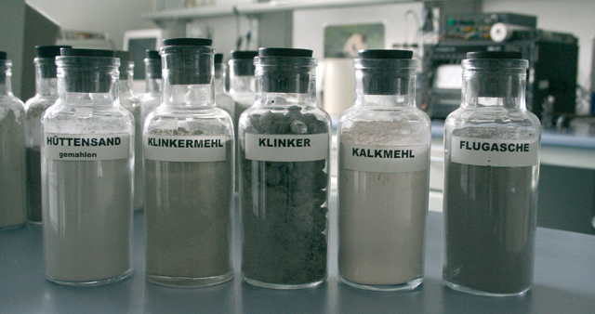

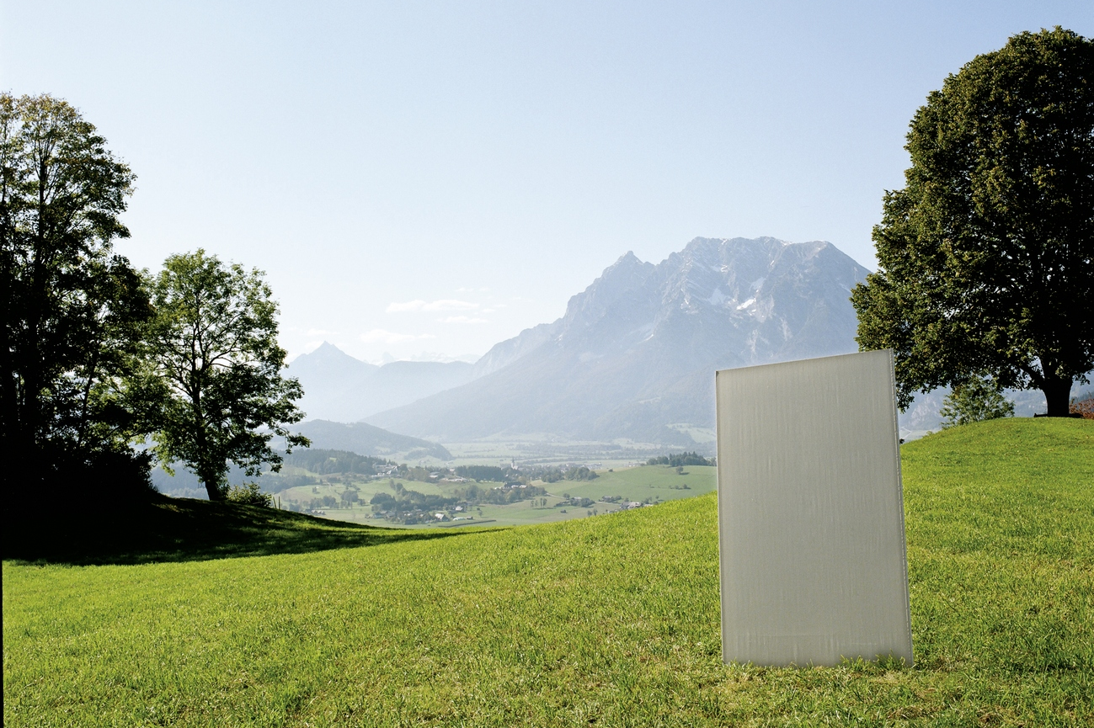

Imprint

Publisher:

Bau EPD GmbH

Seidengasse 13/3
A-1070 Vienna
Austria
http://www.bau-epd.at
office@bau-epd.at

© Bau EPD GmbH

Picture credits frontpage: Vereinigung der Österreichischen Zementindustrie – (VÖZ)

Tracking of versions

Version | Comments | Date of changes
0.0 | First draft by Florian Gschösser based on IBU-PCR | 2023-01-11
0.1 | Editorial changes Sarah Richter due to adaptations for all PCR-B (here was worked in parallel, all PCR will be reissued at the beginning of March, addition of accreditation mark, indication of CF factors, editorial changes, title page EPD labelling energy mix approach). | 2023-02-10
0.2 | Revision based on input from PCR panel and close interested parties related to members of the PGF. | 2023-04-03
0.3 | Editorial revision for public release to solicit comments from broader interested parties. | 2023-04-06

Contents

1. Scope 5
Requirements on the layout of the EPD 5
Content of the EPD 5
1. General information 8
2. Product 9
2.1 General product description 9
2.2 Application field 9
2.3 Standards, guidelines and regulations relevant for the product 9
2.4 Technical data 10
2.5 Basic/auxiliary materials 11
2.6 Production 12
2.7 Packaging 13
2.8 Conditions of delivery 13
2.9 Transport 13
2.10 Processing/ installation 14
2.11 Use stage 14
2.12 Reference service life (RSL) 14
2.13 Reuse and recycling 14
2.14 Disposal 15
2.15 Further information 15
3. LCA: Calculation rules 15
3.1 Declared unit/ Functional unit 15
3.2 System boundary 15
3.3 Flow chart of processes/stages in the life cycle 17
3.4 Estimations and assumptions 17
3.5 Cut-off criteria 17
3.6 Data sources 17
3.7 Data quality 17
3.8 Reporting period 17
3.9 Allocation 18
3.10 Comparability 18
4. LCA: Scenarios and additional technical information 18
4.1 A1-A3 product stage 18
4.2 A4-A5 Construction process stage 19
4.3 B1-B7 use stage 19
4.4 C1-C4 End-of-Life stage 21
4.5 D Potential of reuse and recycling 21
5. LCA: results 22
6. LCA: Interpretation 26
7. Literature 27
8. Directory and Glossary 27
8.1 List of figures 27
8.2 List of tables 27
8.3 Abbreviations 28

Scope
This document contains the Requirements on an Environmental Product Declaration (EPD) as per EN 15804 and ISO 14025 and requirements of Bau EPD GmbH.

The document applies to cements according to the following standards:
- ÖNORM EN 197-1 Cement - Part 1: Composition, requirements and conformity criteria for ordinary cement
- ÖNORM B 3327-1 Cements according to ÖNORM EN 197-1 for special uses - Part 1: Additional requirements
- ÖNORM EN 14216 Cement - Composition, requirements and conformity criteria for special cements with very low heat of hydration
- ÖNORM EN 197-5 Cement - Part 5: Portland composite cement CEM II/C-M and composite cement CEM VI
- ÖNORM EN 197-6 Cement - Part 6: Cement with recycled constituents
- Cements with national technical approval

The requirements on the EPD include:
- Requirements from EN ISO 14025
- Requirements on the EN 15804 standard as a European core EPD
- Requirements from ÖNORM EN 16908 cement and building lime ― environmental product declarations ― product category rules in addition to EN 15804
- Complementary requirements on EPD of Bau EPD GmbH

The calculation rules for the Life Cycle Assessment and Requirements on the project report are specified in a separate document – “Management System Handbook chapter 5” of Bau EPD GmbH.

Requirements on the layout of the EPD
Bau-EPD GmbH determines the following features with regard to the layout of the EPD:

- The document on hand defines the format template for EPD-document that is to fill in (Word file „Format template EPD Bau EPD GmbH“, download at www.bau-epd.at).
- The content of an EPD is not limited in length of text.
- The layout of the front page of the EPD is defined and picture material must be accorded with Bau EPD GmbH (not more than 4 MB).
- On the last page of the EPD the publishing institution as well as the programme operator (Bau EPD GmbH in both cases), the LCA practitioner and owner of the declaration must be indicated with a logo and full address (including telephone number, fax number, email and website).
- Generally the font „Calibri“ must be used.
- In addition to the EPD as Microsoft Word format an Excel-document (BAU EPD M-DOCUMENT 8- excel-file for electronic data transfer Editor baubook ECO Platform) must be created including the result tables for electronic transfer and complying to EN 15942 (ITM Matrix). The templates of Bau EPD GmbH must be used, for these tables also serve to forward data to database owners (ECO Platform/ECO Portal, OEKOBAUDAT and BAUBOOK).

Content of the EPD
The following format template respective guidance describes the required structure of the EPD document including the required content for each individual chapter.
In addition to that, this document is giving specific notes for the creation of an EPD for Cement and specific LCA calculation rules for Cement that must be considered when creating the EPD and underlying LCA study.

Parts of the content that are considered as additional information of optional character (=not required as per international standard and/or guidelines from ECO Platform) are marked in lilac colour. This information is free to choose whether to declare or not and indications can be delivered by the owner of the declaration on optional basis.

Legend:
Blue: required content for each chapter
Turquoise: specific requirements for EPD of materials from the scope of the PCR
Green: specific LCA rules for EPD of material from the scope of the PCR
Violet: additional information of optional character

EPD - ENVIRONMENTAL PRODUCT DECLARATION

As per ISO 14025 and EN 15804
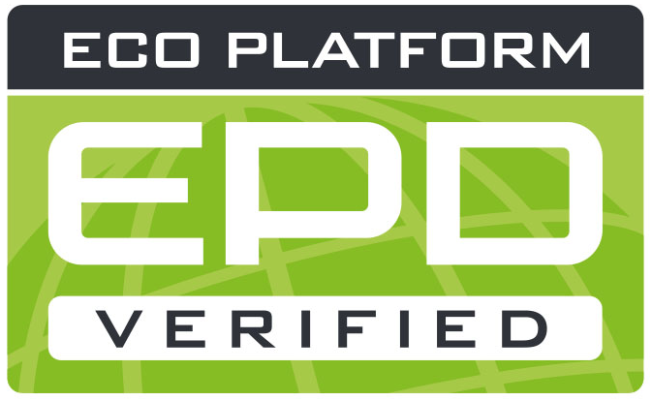
OWNER AND Publisher Bau EPD GmbH, A-1070 Wien, Seidengasse 13/3, www.bau-epd.at
Programme Operator Bau EPD GmbH, A-1070 Wien, Seidengasse 13/3, www.bau-epd.at
HOLDER of the Declaration Name of declaration holder
Declaration Number To be accorded with Bau EPD GmbH
Issue Date Date
Valid To Date
NUMBER OF DATASETS Number
ENERGY MIX APPROACH MARKET BASED APPROACH

Name and description of product
Name of declaration owner

picture
To be accorded with declaration owner and Bau EPD GmbH
(Note: photographic rights must be clarified and cited)

Company logo of declaration owner

Contents:

Content of the EPD Fehler! Textmarke nicht definiert.
1. General information Fehler! Textmarke nicht definiert.
2. Product Fehler! Textmarke nicht definiert.
2.1 General product description Fehler! Textmarke nicht definiert.
2.2 Application field Fehler! Textmarke nicht definiert.
2.3 Standards, guidelines and regulations relevant for the product Fehler! Textmarke nicht definiert.
2.4 Technical data Fehler! Textmarke nicht definiert.
2.5 Basic/auxiliary materials Fehler! Textmarke nicht definiert.
2.6 Production Fehler! Textmarke nicht definiert.
2.7 Packaging Fehler! Textmarke nicht definiert.
2.8 Conditions of delivery Fehler! Textmarke nicht definiert.
2.9 Transport Fehler! Textmarke nicht definiert.
2.10 Processing/ installation Fehler! Textmarke nicht definiert.
2.11 Use stage Fehler! Textmarke nicht definiert.
2.12 Reference service life (RSL) Fehler! Textmarke nicht definiert.
2.13 Reuse and recycling Fehler! Textmarke nicht definiert.
2.14 Disposal Fehler! Textmarke nicht definiert.
2.15 Further information Fehler! Textmarke nicht definiert.
3. LCA: Calculation rules Fehler! Textmarke nicht definiert.
3.1 Declared unit/ Functional unit Fehler! Textmarke nicht definiert.
3.2 System boundary Fehler! Textmarke nicht definiert.
3.3 Flow chart of processes/stages in the life cycle Fehler! Textmarke nicht definiert.
3.4 Estimations and assumptions Fehler! Textmarke nicht definiert.
3.5 Cut-off criteria Fehler! Textmarke nicht definiert.
3.6 Data sources Fehler! Textmarke nicht definiert.
3.7 Data quality Fehler! Textmarke nicht definiert.
3.8 Reporting period Fehler! Textmarke nicht definiert.
3.9 Allocation Fehler! Textmarke nicht definiert.
3.10 Comparability Fehler! Textmarke nicht definiert.
4. LCA: Szenarios and additional technical information Fehler! Textmarke nicht definiert.
4.1 A1-A3 product stage Fehler! Textmarke nicht definiert.
4.2 A4-A5 Construction process stage Fehler! Textmarke nicht definiert.
4.3 B1-B7 use stage Fehler! Textmarke nicht definiert.
4.4 C1-C4 End-of-Life stage Fehler! Textmarke nicht definiert.
4.5 D Potential of reuse and recycling Fehler! Textmarke nicht definiert.
5. LCA: results Fehler! Textmarke nicht definiert.
6. LCA: Interpretation Fehler! Textmarke nicht definiert.
7. Literature Fehler! Textmarke nicht definiert.
8. Directory and Glossary Fehler! Textmarke nicht definiert.
8.1 List of figures Fehler! Textmarke nicht definiert.
8.2 List of tables Fehler! Textmarke nicht definiert.
8.3 Abbreviations Fehler! Textmarke nicht definiert.

General information

Product name  Name and description of product | Declared Product / Declared Unit  Description of the declared product and declared unit/functional unit  Number of datasets in EPD Document(s): XX  Range of validity  The products considered in the data of the life cycle assessment and for which the declaration applies must be named.  In the case of an average EPD, this type of EPD must be pointed out.  The representativeness of the declaration must be shown with regard to the production volume covered by the life cycle assessment and the technology used. Likewise, the range of fluctuation of the product group considered, must be specified in the interpretation.
Declaration number
To be accorded with Bau EPD GmbH
Declaration data
Specific data
Average data

Declaration based on:
MS-HB version dated dd.mm.yyyy:
Name of PCR
PCR Code
Version
(PCR tested and approved by the independent expert committee
= PKR-Gremium)
The owner of the declaration is liable for the underlying information and evidence; Bau EPD GmbH is not liable with respect to manufacturer
information, life cycle assessment data and evidence.
Type of Declaration as per EN 15804  From cradle to ... .....  LCA-method: (i.e. Cut-off by classification) | Database, Software, Version  Declaration of backround database, Software used and both its versions  Version Characterisation Factors: Quelle, Version
Author of the Life Cycle Assessment  Name of the author  Institution, Address  website | The CEN standard EN 15804:2014+A1 serves as the core-PCR.  Independent verification of the declaration according to ISO 14025:2010  internally externally  Verifier 1: Name  Verifier 2: Name
Holder of the Declaration  Name of the manufacturer/owner  Institution, Address  website | Owner, Publisher and Programme Operator  Bau EPD GmbH  Seidengasse 13/3  1070 Vienna  Austria

DI (FH) DI DI Sarah Richter
Head of Conformity Assessment Body

Academic Title Name Academic Title Name,
Verifier Verifier

Note: EPDs from similar product groups from different programmes might not be comparable.

Product

General product description

For the product description the characteristics of the declared product must be described. In case of average EPD (“sector or branch” EPD) all declared products must be described separately.

Indications for the general product description:
- Separate description of products/materials for each product standard applicable, citing the product types and names.
- Description of characteristic components.
- All factory locations for the respective product categories must be declared, alternatively a reference can be made to an overview in an appendix (mandatory information in the project report, voluntary information in the EPD document)

Specific notes for the creation of an EPD for Cement:

Separate description of the cements per applicable product standard.

Example:
Cement is a hydraulic binder, i.e. a finely ground inorganic substance which, when mixed with water, produces cement paste, which sets and hardens by hydration and, after hardening, remains solid and stable in space even under water.

Cement according to ÖNORM EN 197-1:2018, ÖNORM EN 197-5:2022, ÖNORM B 3327-1:2005 or ÖNORM EN 14216:2015 consists of

- Main cement constituents (Portland cement clinker, granulated blastfurnace slag, pozzolana, fly ash, burnt shale, limestone or silica fume),
- Cement constituents (after appropriate preparation, improve the physical properties of cement due to their particle size distribution),
- calcium sulphate (added to the other constituents of cement during its production to regulate the setting behaviour), and
- (cement) additives (the total quantity of additives must not exceed a mass proportion of 1.0 % in relation to the cement (excluding pigments)).

Portland cement clinker is produced from a mixture of raw materials that is heated in a kiln at a temperature of over 1400 °C until it sintered. Portland cement clinker consists mainly of calcium silicates and calcium aluminates.

The declared cement belongs to the main cement type (CEM I, CEM II, CEM III....) according to ÖNORM EN 197-1:2018.

Application field

The use and application purpose of the named products are to specify. The individual applications (including functions) must be declared as a text or table format.
Specific notes for the creation of an EPD for Cement:

For the declared cements, the main areas of application shall be shown accordingly.

Example:
The main application of cement is the production of concrete according to ÖNORM EN 206:2021 or according to ÖNORM B 4710-1:2018, cement screed according to ÖNORM EN 13813:2003 or ÖNORM B 3732:2016 and cement mortar according to ÖNORM EN 998-1:2017 and ÖNORM EN 998-2:2017.

Standards, guidelines and regulations relevant for the product

The respective standard and/or general technical approval or comparable national regulation can be indicated.

Optional: Documentation under the frame of CE -certification such as certificates of constancy of performance, certificates of conformity of the internal production control on the manufacturer’s site, Declarations of performance, Official certificates of registration, European Technical Assessments or Technical permissions of construction industry can be cited.

Specific notes for the creation of an EPD for Cement:

The rules of application applicable to cements shall be mentioned (e.g. standards, guidelines, other regulations).

Example:
Regulation (EU) No 305/2011(CPR) applies to the placing on the market of the product in the EU/EFTA (except Switzerland). The product requires a declaration of performance taking into account EN 197-1:2018 or EN 14216:2015 and CE marking. The cements CEM II/C and CEM VI require an application approval according to ÖNORM EN 197-5:2022. Product-relevant standards for cements in Austria are shown in Table 1.

Table 1: Product specific standards
Standard | Title
ÖNORM EN 197-1:2018 | Cement - Part 1: Composition, requirements and conformity criteria for ordinary cement
ÖNORM B 3327-1:2005 | Cements according to ÖNORM EN 197-1 for special uses - Part 1: Additional requirements
ÖNORM EN 14216:2015 | Cement - Composition, requirements and conformity criteria for special cements with very low heat of hydration
ÖNORM EN 197-5:2022 | Cement - Part 5: Portland composite cement CEM II/C-M and composite cement CEM VI
ÖNORM EN 197-6:2022 | Cement - Part 6: Cement with recycled building materials
Nationale bautechnische Zulassungen | Cements with national technical building approval

Technical data

For products carrying a CE marking as per Construction Products Regulation (CPR) the EPD must declare at least the same technical data as required and indicated in the declaration of performance of the manufacturer. What kind of data is required in each individual case is to learn from the document underlying the CE marking: any Harmonized European Standard or European Technical Assessment (ETA).
Additional technical data must be listed if relevant for product distinction or specification.

Specific notes for the creation of an EPD for Cement:
For declared cements, at least the following technical data shall be provided:

Table 2: Technical data of the declared cement product
Characterization | Value | Unit
Mean raw density or raw density range |  | kg/m3
Class of standard compressive strength according to ÖNORM EN 197-1:2018 |  | N/mm²

For specific EPD the technical data of the product must be declared as required in Table 2.
For average EPD (“Sector or Branch-EPD“, “Group EPD” or “EPD from Associations”) Table 2 must be filled, average values or ranges are accepted, in addition a note stating „see product sheets“ pointing to single technical product sheets can be cited. Technical data must be provided by the manufacturers. The manufacturers are to ensure that the relevant data are accessible, and the LCA-practitioner must indicate the sources where the technical data can be downloaded.
In this case the average value of nominal density/ weight per m² used for calculating the LCA must be declared as an additional information in chapter 3.1.
Note:
When averaging, it should be taken into account that, with regard to possible grouping into classes, the gross density is more decisive than the application according to EN 16783.

In case of declaring average values ÖNORM EN 16783 chapter 6.3.6 must be considered:
Grouping of products and declaring average values is allowed without reporting differences,
if the differences in each impact category are lower than 25 %. In other cases, the differences in the
impact categories shall be reported together with average values.

Basic/auxiliary materials

The product components and/or contents and ingredients must be declared in mass-% to enable the user of the EPD to understand the composition and structure of the product in delivery status. These indications shall also support security and efficiency in installation, use and disposal of the product.

The declaration of mass-% can be accurate numbers or a range by analogy with REACH . The mass of components that make up less than 1 mass-% of the total product mass can be declared with < 1 mass-%.

The declaration of material product content must list at least those substances contained in the product which are included in the “Candidate List of Substances of Very High Concern for Authorization” where their contents exceed the limit values (0.1 mass-% on product level) for registration by the European Chemicals Agency (ECHA). If substances and preparations lose their hazardous features during manufacturing (e.g. after a complete chemical reaction) they are exempted from the obligation of declaration.
If the content of the material is below the limit of ECHA the following note must be stated in the EPD:
„The content of XXXX is below the limit values of the registration by the European Chemicals Agency (ECHA). Interpreting statements such as “… free of …” or “… are entirely harmless …” are not permissible.

The product components must be described in detail, so that their sort of product is clear, but the protection of sensitive data is assured, and company secrets are not revealed.
For additives, the function and substance class respective chemical group (i.e. hydraulic binders) must be stated. In addition to that all auxiliary materials and additives that stay within the product must be declared.

Table 3: base materials in mass-% (example)

Components | Function | Mass fraction in percent
Portland cement clinker (K) | Primary raw material
Pozzolana natural (P) | Primary raw material
Pozzolana/tempered clay (Q) | Primary raw material
burnt slate (T) | Primary raw material
Limestone (L) | Primary raw material
limestone (LL) | Primary raw material
natural gypsum | Primary raw material
Anhydrite | Primary raw material
Stone powder | Primary raw material
AMZ marl | Primary raw material
Gravel-clay mixture | Primary raw material
Marble sand | Primary raw material
granulated blastfurnace slag (S) | Secondary raw material
Fly ash rich in silica (V) | Secondary raw material
Fly ash rich in lime (W) | Secondary raw material
Silica fume (D) | Secondary raw material
FGD gypsum | Secondary raw material
Filter dusts | Secondary raw material
Bypass dusts | Secondary raw material
Slags | Secondary raw material
Moulding gypsum, broken gypsum planks | Secondary raw material
Coarse ash | Secondary raw material
Gypsum from microbial applications | Secondary raw material
Ferrous sulphate | Chromate reducer
Ethylene glycol | Grinding aid

Production

The process of production must be described and illustrated with a simple figure (i.e. flow chart). In case of average EPD the production processes of all sites must be described respective a useful summary must be included and a list of all production sites must be provided in an annex. Quality management systems, eco management systems etc. can be referred to.

Specific notes for the creation of an EPD for Cement:
Example:
The most important cement raw materials limestone, clay and their natural mixture, limestone marl, are extracted in quarries mainly by blasting. Clay can be removed directly from the quarry face with bucket chain, bucket wheel or dragline excavators. Vehicles transport the coarse raw material to hammer crushers where it is broken into crushed stone. The crushed stone can then be transported from the quarry to the cement plant, e.g. on conveyor belts. The raw material components are fed in predetermined mixing ratios via dosing equipment in a mill and finely ground into raw meal.

In Austria, cement clinker is produced exclusively by the dry process in rotary kilns with cyclone preheaters. In the preheater, the raw meal is heated to over 800 °C by the exhaust gases from the rotary kiln. The material exiting the lower cyclone stage of the preheater enters the rotary kiln, which is inclined at an angle of 3 - 4°. In the rotary kiln, the material is moved from the kiln inlet towards the burner installed at the kiln outlet. In the so-called sintering zone, the firing material reaches temperatures of about 1450 °C. A clinker cooler is connected to the kiln outlet. After burning and cooling, the clinker is stored in silos or closed halls to avoid clinker dust emissions as much as possible.

For the production of cement, the clinker is finely ground separately or together with other main constituents. A sulphate carrier is added to the ground material to control solidification. Gypsum or anhydrite from natural sources or from flue gas desulphurisation plants is used for this purpose. The finished cement is usually stored in silos, from which the cement is shipped as sacks or silos.

To ensure cement quality, quality assurance systems are installed in all Austrian cement plants today, which are based on the requirements for factory production control according to ÖNORM EN 197-2:2020 [15] or the standard for quality management systems ÖNORM EN ISO 9001:2015 [16]. In addition to the concrete specifications for process control and monitoring of intermediate and final products, QM systems according to ÖNORM EN ISO 9001:2015 [16] also include measures to improve the organisational structure and the production processes as a whole.

Figure 1 shows the schematic representation of the cement production process from quarry to dispatch.

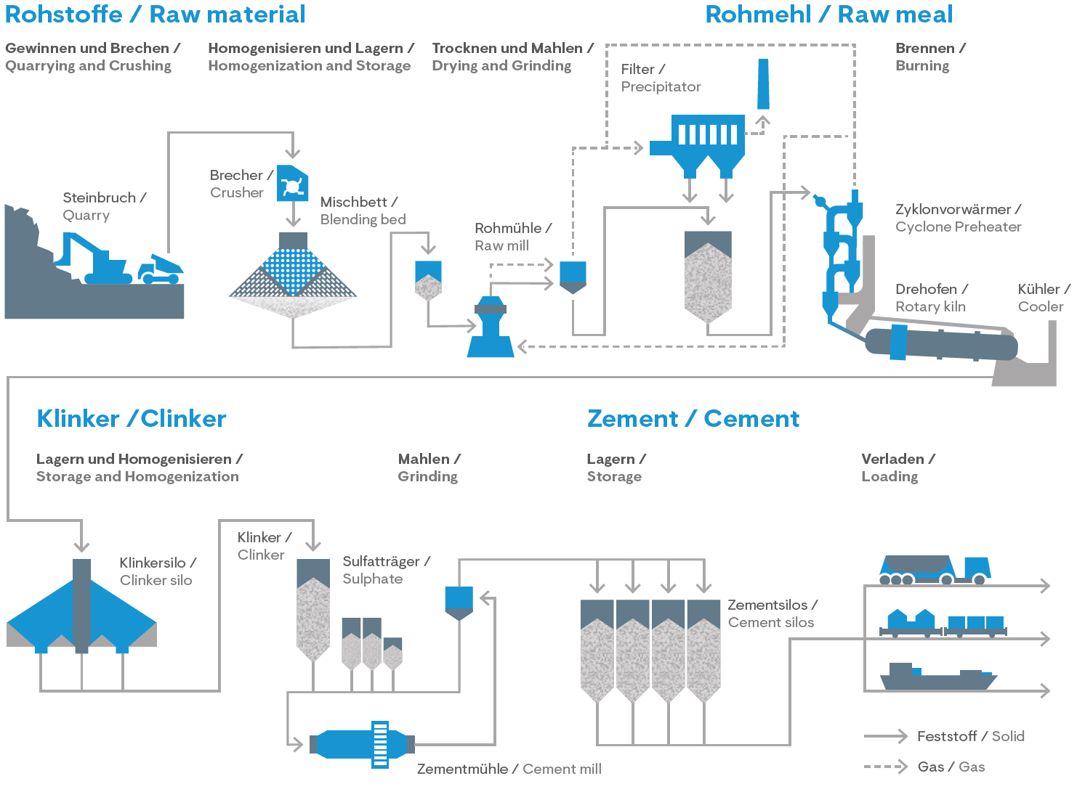

Figure 1: Example of a flow chart/graphic production stage

Packaging

Information concerning each component of packages:

Type (Foil, pallets, etc.),
Material (Paper, Polyethylene; including origin, e.g. recycled paper) and
Possibilities of reuse (e.g. multi way pallets).

Specific notes for the creation of an EPD for Cement:
A very small proportion of the cement reaches the customer as bagged goods in paper bags. PE shrink films (EWC 150102), wooden pallets (EWC 150103) and steel strapping (EWC 150104) are used as packaging materials. Under the Interseroh system, these packaging materials are returned to the cement manufacturers.
This EPD only considers silo goods and does not take into account packaging material for the very small market share of bagged goods.

Conditions of delivery

Written description of conditions of delivery, units of delivery, size and dimension as well as requirements on storage important for the declared product(s).
Specific notes for the creation of an EPD for Cement:
Cement is a powdery bulk material and is predominantly delivered in bulk and loaded onto road or rail vehicles. A very small proportion of the cement reaches the customer as bagged goods.

Transport

Description of delivery (Route and means of transport).
Specific notes for the creation of an EPD for Cement:
Example:
Cement is a homogeneous bulk good that is transported either by truck or by rail. The declared cement is mainly delivered to local sales markets.

Processing/ installation

Description of way of treatment, used machines, tools, dust collection etc., auxiliary materials as well as measures of noise reduction. Notes regarding recognized rules of engineering, work safety or protection of the environment can be included.
References to detailed processing directives and referrals to user safety (safe use instruction sheets) of the manufacturer are required.

Specific notes for the creation of an EPD for Cement:
Example:
The main application of cement is the production of concrete, screed or mortar. Mixing cement and water produces cement paste, which coats the individual grains of aggregate in the corresponding building material and firmly bonds them together by hardening. In the process, the cement paste, which is liquid after the addition of water, passes into the solid cement stone.

Today, fresh concrete is produced almost exclusively in ready-mixed concrete plants, on large construction sites or in precast factories in medium to large mixing plants. Cement screed and cement mortar are mixed directly on the construction site or transported from mixing plants.

Use stage

Notes describing specific features of the material composition relevant for the use stage.

Specific notes for the creation of an EPD for Cement:
Example:
Since cement is used as an intermediate product in the production of various cement-bound building materials (ready-mixed concrete, precast concrete, cement screed, etc.), it is usually not possible to provide information on the environmental impacts from the product during the construction phase, the use phase and the disposal phase, as these depend significantly on the use of the cement. The EPD therefore considers the life cycle modules A1-A3 (raw material extraction and processing, transport to the manufacturer, production). The construction phase, the use phase and the disposal phase are not considered in the life cycle assessment for cement. This is permissible according to ÖNORM EN 15804, as cement fulfils the conditions for this specified in the standard (see 3.2 System boundary).

Reference service life (RSL)

The indication of the reference service life (RSL) is imperative for EPDs covering the complete use stage (modules B1-B7), or if a use stage scenario is described, which refers to the lifetime of the product (“from cradle to grave”).
The RSL must refer to the declared technical and functional quality of the product. It must be established in line with all of the specific rules in the European product standards and must also take consideration of the ISO 15686-1, -2, -7 and -8 standards.
Where information is available for deriving the RSL from harmonized European product standards, such data has priority.
The assumption underlying the calculation of the RSL and for those only the RSL can be declared must be stated. Influence on aging as per recognized rules of engineering.

Specific notes for the creation of an EPD for Cement:
Example:
Not relevant for cement (see 2.11 Use phase and 3.2 System boundary).

Reuse and recycling

Possibilities and scenarios of reuse and recycling must be described.

Specific notes for the creation of an EPD for Cement:
Example:
Not relevant for cement (see 2.11 Use phase and 3.2 System boundary).

Disposal

The different ways of disposal must be described.
The EAK-waste disposal code (Disposal code following the European list of waste) must be declared.
Specific notes for the creation of an EPD for Cement:

Example:
If cement needs to be disposed of, it should be cured with water and disposed of in accordance with local authority regulations. The hardened product is then disposed of as for concrete waste and concrete slurries.

Waste code according to the Austrian Waste Catalogue Ordinance or the European Waste Catalogue (EWC) depending on the origin: 17 01 01 [18] (concrete) or 10 13 14 [18] (concrete waste and concrete slurry).

The EPD does not consider the disposal phase due to the arguments given in 2.11 Use phase and 3.2 System boundary.

Further information

Optional details, indication of reference source for additional information, e.g. websites…

LCA: Calculation rules

Declared unit/ Functional unit

The declared resp. functional unit, the mass reference and the conversion factor to 1 kg must be declared in a table.

Specific LCA calculation rules for Cement:
The declared unit is 1 tonne of the assessed cement.

Table 4: Declared unit 1 t
characterization | value | unit
declared unit | 1 | t
gross density for conversion into kg |  | kg/ m³
Mass-related volume |  | m³/kg

If average results of different products are declared, the methods of calculating the average values must be explained.
In this case the average value of nominal density/ weight per unit used for calculating the LCA must be declared as an additional information.

System boundary

The type of EPD with regard to the applied system boundaries must be specified in the EPD. All building products and materials must declare modules A1-A3, modules C1-C4 and module D. The following EPD types may be specified:
• from the cradle to the factory gate with modules C1-C4 and module D (A1-A3 + C + D);
• from the cradle to the factory gate with options, modules A1-A3, C1-C4 and D (A1-A3 + C + D and additional modules. The additional modules may be one or more modules selected from A4 to B7);
• from cradle to grave and module D (A + B + C + D)
Exceptions to this rule are specified in EN 15804+A2, chapter 5.2.
All declared life cycle stages (modules) are to be marked with an "X" in Table 7. Undeclared modules are to be marked with ND (= not declared).
Table 5: Declared life cycle stages
PRODUCT STAGE |  |  | CON-STRUCTION PROCESS STAGE |  | USE STAGE |  |  |  |  |  |  | END-OF-LIFE STAGE |  |  |  | BENEFITS  AND LOADS BEYOND THE SYSTEM BOUNDARIES
A1 | A2 | A3 | A4 | A5 | B1 | B2 | B3 | B4 | B5 | B6 | B7 | C1 | C2 | C3 | C4 | D
Raw material supply | Transport | Manufacturing | Transport from the gate  to the site | Construction, installation | Use | Maintenance | Repair | Replacement | Refurbishment | Operational energy use | Operational water use | De-construction, demolition | Transport | Waste processing | Disposal | Reuse-  Recovery-  Recycling-  potential
x | x | x | x | x | x | x | x | x | x | x | x | x | x | x | x | x
X = included in LCA; MND = Module not declared
The modules assessed in the LCA study must be described shortly. It should be made apparent, which processes are calculated in which module and how the system boundaries to nature resp. to other product systems are set (if relevant for the declared product).

If not all modules are declared in an EPD, a clear justification must be given.

Specific LCA calculation rules for Cement:
Type of LCA or EPD: from the cradle to the factory gate
The selected system boundaries cover the production of cement, including raw material extraction, up to the finished product at the factory gate.
Since cement is used as an intermediate product in the production of various cement-bound building materials (ready-mixed concrete, prefabricated concrete, cement screed, etc.), it is usually not possible to provide information on the environmental impacts from the product during the construction phase, the use phase, and the disposal phase, since these are largely dependent on the use of the cement. The EPD therefore considers the life cycle modules A1-A3 (raw material extraction and processing, transport to the manufacturer, production). The construction phase, the use phase and the disposal phase are therefore not considered. This is permissible according to ÖNORM EN 15804:2022, as cement fulfils the following conditions specified in the standard:
- The product or material is physically integrated with other products during installation so that it cannot be physically separated from them at the end of life.
- The product or material is no longer identifiable at the end of its life as a result of a physical or chemical transformation process.
- The product or material does not contain biogenic carbon.
The key input material for cement is the cement clinker. The production of the clinker, as far as it comes from the same producer as the cement or as far as knowledge about its production is available, is to be modelled with primary data (in modules A1-A3). Since clinker and cement production can also take place separately or in the case that the clinker is purchased and no detailed information on clinker production is available, clinker production can also be taken into account purely under A3 (as an intermediate product according to EN 15804 - 6.3.5.2) and, if necessary, mapped using life cycle inventories from corresponding databases.
Module A1: Raw material extraction and processing:

- Raw material extraction for cement and clinker production
- this includes, for example, the extraction of calcareous materials such as limestone or marl, and clayey materials such as clay or clay slate
- Extraction of primary fuels
- Important primary energy sources used in cement or clinker production are hard coal, petroleum coke, lignite and natural gas
- Processing of raw materials, fuels and co-products from other industries (e.g. blast furnace slag, fly ash)
Module A2: Transport to the cement plant and internal transports
- Transport of raw materials, fuels and co-products from other industries to the cement or grinding plant
- Internal transports in the cement or grinding plant
- if applicable, transport of Portland cement clinker and other cement constituents to the grinding plant
Module A3: Cement production
- Clinker production: heating of the raw material mixture in a kiln plant until sintering (at a temperature of over 1400 °C)
- If necessary, the entire clinker production, if the clinker is supplied accordingly
- Grinding of the raw materials
- Grinding and mixing of the main and secondary cement constituents
- Storage of the cement, preparation for dispatch

Flow chart of processes/stages in the life cycle

A meaningful flow chart describing the manufacturing process shall give further aid to comprehension. The flow chart must be subdivided at least into the phases of life cycle declared (production, use, end-of-life). The phases can be partitioned into appropriate process stages.

Estimations and assumptions

The assumptions and assessments that are important for the interpretation of the life cycle assessment are to be listed here.

Cut-off criteria

The application of the cut-off criteria according to MS-HB Chapter 5.5.3 must be documented here.

Data sources

The quality of the collected data must be described.

Data quality

The sources of the backround data sets must be declared. If necessary, additional information on the quality of the used data sets shall be made (estimations). The issuing year of the used data material must be indicated.

Reporting period

The period under review must be documented (in case of average EPD this would be the basis of the calculated average).

Allocation

The allocations of relevance for calculation (appropriation of expenses across various products) must be indicated, at least:
- System boundary settings/allocation in the use of recycled and/or secondary raw materials
- Allocation concerning co-products
- Allocation of energy, auxiliary and operating materials used for individual products in a factory
- Loads and credits from recycling or energy recovery of packaging materials and production waste
- Loads and credits from recycling or energy recovery from the end of life of the product

whereby reference must be made to the modules in which the allocations are performed.
Detailed regulations concerning calculation of secondary materials and allocation MS-HB chapter “LCA rules” apply in all studies.

Spezifische Ökobilanzregeln für Zement:
When allocating the materials "blast furnace slag" and "fly ash" required for the production of cement, an economic allocation must be applied according to ÖNORM EN 15804. The loads from granulation, dewatering and transport of the blast furnace slag are to be allocated 100% to the granulated blast furnace slag. Deviations from this rule shall be justified with regard to their compliance with EN 15804.

In accordance with the polluter pays principle according to ÖNORM EN 15804 or CEN/TR 16970 - Table 2, the following applies to the incineration of waste in the cement product system:
- The waste status shall be substantiated in the project report by e.g. stating the waste code(s) (or comparable evidence).
- CO2 emissions from the incineration of verified wastes are not attributed to the cement production system. They shall nevertheless be calculated. In the case of emissions from biogenic wastes, the sum of the emissions in A1-A3 shall normally always be indicated as 0 (see normative annex EN15804 C2.4). If biogenic waste was taken into account, this must also be indicated as a note under the LCA table.
- The following note is inserted directly below the results table: "For all GWP indicators in A1 - A3, the net values are declared. The waste status of the (waste-based) fuels has been demonstrated. Gross emissions (i.e., including CO2 from waste incineration) are x1 kg CO2 eq./t (GWP-total), x2 kg CO2 eq./t (GWP-fossil), x3 kg CO2 eq./t (GWP-biogenic).", where x1, x2 and x3 are the respective sums of net values and emissions from incineration of verified waste.
- All corresponding calculations shall be documented in the project report.
- All non-CO2 emissions are basically attributed to the cement production system

Comparability

With reference to comparability of EPD data the following facts must be mentioned:

Comparison or benchmarking of EPD data is only possible, if all compared data sets are calculating following EN 15804 in the same version, the same programme specific PCR-rules or other additional rules. The same backround data sources and software versions must be applied. Moreover, the context of the function in the building or product specific features of performance must be considered.

LCA: Scenarios and additional technical information

The following information is mandatory to give for all declared modules, for modules not declared it is optional. If need, additional information can be declared.

A1-A3 product stage

Following EN 15804 no scenario documentation is required for A1-A3 for the declaration and calculation of these modules lies within the responsibility of the manufacturer and must not be altered by the LCA practitioner.
Note: the masses of packaging per declared unit must be indicated, this is especially important if A5 is not declared.

A4-A5 Construction process stage

Table 9 and the units listed must be used for calculation the environmental impact of the transport phase.
Table 10 and the units listed must be used for calculation the environmental impact of the installation into the building.

Table 6: Description of the scenario „Transport to building site (A4)“
Parameters to describe the transport to the building site (A4) | Quantity per unit
Average transport distance | km
vehicle type, Commission Directive 2007/37/EC (European Emission Standard) | -
Fuel type and average consumption of vehicle | l/100 km
Maximum transport mass | tons
Capacity utilisation (including empty returns) | %
Bulk density of transported products | kg/m³
Volume capacity utilisation factor (factor: =1 or <1 or ≥ 1 for compressed or nested packaged products) | -
^{x)} The table must be filled with reference to the information available from the datasets used (i.e. in case of transport by ship). The datasets used must be noted in a footnote.

Table 7: Description of the scenario „Installation of the product in the building (A5)“ as per table 8 in ÖNORM EN 15804
Parameters to describe the installation of the product in the building (A5) | Quantity per unit
Ancillary materials for installation (specified by material); | Meaningful unit
Water use | m³
Other resource use | kg
Electricity demand | kWh or MJ
Other energy carrier(s): ……………. | kWh or other unit (e.g. litres)
Wastage of materials on the building site before waste processing, generated by the product’s installation (specified by type) | kg
Output materials (specified by type) as result of waste processing at the building site e.g. of collection for recycling, for energy recovery, disposal (specified by route) | kg
Direct emissions to ambient air, soil and water | kg

B1-B7 use stage

Reference Service life: [a]
The parameters and the units listed in the following tables must be used for calculation the environmental impact of the use stage (B2-B7). The tables can be excluded if no input or output happens. In this case a note of explanation would be sufficient: “In module BX-BY no material resp. mass flows occur, input +/- output = 0

Table 8: Description of the scenario „maintenance (B2)“ based on table 9 in EN 15804
Parameters maintenance (B2) | value | unit
Maintenance process |  | Description or source where description can be  found
Maintenance cycle |  | Number per RSL or year ª
Ancillary materials for maintenance, e.g.  cleaning agent, specify materials |  | Kg/cycle
Waste material resulting from maintenance (specify materials) |  | kg
Net fresh water consumption during maintenance |  | m³
Energy input during maintenance, e.g. vacuum cleaning, energy carrier type, e.g. electricity, and amount, if applicable and relevant |  | kWh

Table 9: Description of the scenario „repair (B3)“
Parameters repair (B3) | value | unit
Repair process |  | Description or source where description can be  found
Inspection process |  | Description or source where description can be  found
Repair cycle |  | Number per RSL or year
Ancillary materials, e.g. lubricant, specify  materials |  | Kg or kg/cycle
Waste material resulting from repair, (specify materials) |  | kg
Net fresh water consumption during repair |  | m³
Energy input during repair, e.g. crane activity,  energy carrier type, e.g. electricity, and amount |  | kWh

Table 10: Description of scenario „replacement (B4)“
Parameters replacement (B4) | value | unit
Replacement cycle |  | Number per RSL or year
Energy input during replacement e.g. crane  activity, energy carrier type, e.g. electricity and  amount if applicable and relevant |  | kWh
Exchange of worn parts during the product’s life cycle, e.g. zinc galvanised steel sheet, specify materials |  | kg

Table 11: Description of scenario „refurbishment (B5)“

Parameters refurbishment (B5) | value | unit
Refurbishment process |  | Description or source where description can be  found
Refurbishment cycle |  | Number per RSL or year
Energy input during refurbishment e.g. crane  activity, energy carrier type, e.g. electricity, and  amount if applicable and relevant |  | kWh
Material input for refurbishment, e.g. bricks, including ancillary materials for the refurbishment process e.g. lubricant, (specify materials) |  | kg or kg / cycle
Waste material resulting from refurbishment (specify materials) |  | kg
Further assumptions for scenario development, e.g. frequency and time period of use, number of occupants |  | Units as appropriate

Table 12: Description of scenarios „energy (B6)“ resp. „Water (B7)“
Parameters energy (B6) and water (B7) | value | unit
Ancillary materials, e.g. lubricant, specify  materials |  | Kg or kg/cycle
Net fresh water consumption |  | m³
Type of energy carrier, e.g. electricity, natural gas, district  heating |  | kWh or m³
Power output of equipment |  | kW
Characteristic performance, e.g. energy efficiency, emissions, variation of performance with capacity utilisation etc. |  | units as appropriate
Further assumptions for scenario development, e.g. frequency and period of use, number of occupants |  | units as appropriate

Specific LCA calculation rules for Cement:

As cement is used as an intermediate product in the production of various cement-bound building materials (ready-mixed concrete, precast concrete, cement screed, etc.), it is usually not possible to provide information on the environmental impacts from the product during the construction phase, the use phase and the disposal phase, as these are largely dependent on the use of the cement. Therefore, the life cycle modules A1-A3 (raw material extraction and processing, transport to the manufacturer, production) are to be considered. The construction phase, the use phase and the disposal phase are not considered. This is permissible according to ÖNORM EN 15804:2022, as cement fulfils the conditions for this specified in the standard.

C1-C4 End-of-Life stage

Short description of processes concerning disposal and scenarios going with that (i.e. for transport).

Table 13: Description of the scenario „Disposal of the product (C1 to C4)“ according to table 12 in EN 15804
Parameters for End-of-Life stage (C1-C4) | value | Quantity per m³ insulation material
Collection process specified by type |  | kg _{collected separately}
 |  | kg collected with mixed construction waste
Recovery system specified by type |  | kg _{for re-use}
 |  | kg _{for recycling}
 |  | kg _{for energy recovery}
Disposal specified by type |  | kg product or material for final deposition
Assumptions for scenario development, e.g. transportation |  | Appropriate units

Specific LCA calculation rules for Cement:
Da Zement als Zwischenprodukt Anwendung bei der Herstellung verschiedener zementgebundener Baustoffe (Transportbeton, Fertigteilbeton, Zementestrich, etc.) findet, ist es meist nicht möglich, Informationen über die Umweltauswirkungen aus dem Produkt während der Errichtungsphase, der Nutzungsphase und der Entsorgungsphase bereitzustellen, da diese maßgeblich von der Nutzung des Zements abhängen. Daher sind die Lebenszyklusmodule A1-A3 (Rohstoffgewinnung und -verarbeitung, Transport zum Hersteller, Herstellung) zu betrachten. Die Errichtungsphase, die Nutzungsphase und die Entsorgungsphase werden nicht berücksichtigt. Dies ist gemäß ÖNORM EN 15804:2022 zulässig, da Zement die in der Norm genannten Bedingungen dafür erfüllt.

D Potential of reuse and recycling

Short description of assumptions for reuse-, recover- and recycling processes.

Table 14: Description of the scenario „re-use, recovery and recycling potential (module D)“
(Substituted primary materials resp. technologies must be declared in a separate footnote (including technical information).
Parameters for module D | value | unit
Materials for reuse, recovery or recycling from A4-A5 |  | %
Energy recovery or secondary fuels from A4-A5 |  | MJ/t resp. kg/t
Materials for reuse, recovery or recycling from B2-B5 |  | %
Energy recovery or secondary fuels from B2-B5 |  | MJ/t resp. kg/t
Materials for reuse, recovery or recycling from C1-C4 |  | %
Energy recovery or secondary fuels from C1-C4 |  | MJ/t resp. kg/t

Specific LCA calculation rules for Cement:
Da Zement als Zwischenprodukt Anwendung bei der Herstellung verschiedener zementgebundener Baustoffe (Transportbeton, Fertigteilbeton, Zementestrich, etc.) findet, ist es meist nicht möglich, Informationen über die Umweltauswirkungen aus dem Produkt während der Errichtungsphase, der Nutzungsphase und der Entsorgungsphase bereitzustellen, da diese maßgeblich von der Nutzung des Zements abhängen. Daher sind die Lebenszyklusmodule A1-A3 (Rohstoffgewinnung und -verarbeitung, Transport zum Hersteller, Herstellung) zu betrachten. Die Errichtungsphase, die Nutzungsphase und die Entsorgungsphase werden nicht berücksichtigt. Dies ist gemäß ÖNORM EN 15804:2022 zulässig, da Zement die in der Norm genannten Bedingungen dafür erfüllt.

LCA: results
The declaration of environmental indicators must be listed in the following tables with reference only to the declared life cycle stages. Indicator values should be declared with three valid digits (eventually exponential form (e.g. 1.23E-5 = 0.0000123). A uniform format should be used for all values of one indicator. It is preferred that the definitions of the environmental indicators are spelled out completely to ensure the best possible readability. If space is needed in case of too many columns the defined abbreviations are accepted.

Table 15: Parameters to describe the environmental impact of mineral insulating products per declared/functional unit
Para-meter | unit | A1-A3 | A4 | A5 | B1 | B2 | B5 | B6 | B7 | C1 | C2 | C3 | C4 | D
GWP total | kg CO₂ eq.
GWP fossil fuels | kg CO₂ eq.
GWP biogenic | kg CO₂ eq.
GWP luluc | kg CO₂ eq.
ODP | kg CFC-11 eq.
AP | mol H⁺ eq.
EP freshwater | kg P eq.
EP marine | kg N eq.
EP terrestrial | mol N eq.
POCP | kg NMVOC eq.
ADPE | kg Sb eq.
ADPF | MJ H_{u}
WDP | m3 Welt eq. entz.
Legende |  | GWP = Global warming potential; luluc = land use and land use change;  ODP = Depletion potential of the stratospheric ozone layer;  AP = Acidification potential, Accumulated Exceedance; EP = Eutrophierungspotenzial;  EP = Eutrophication potential; POCP = Formation potential of tropospheric ozone photochemical oxidants;  ADPE = Abiotic depletion potential for non-fossil resources; ADPF = Abiotic depletion potential for fossil resources WDP = Water (user) deprivation potential, deprivation-weighted water consumption

Table 16: Additional environmental indicators
Parameter | Unit | A1-A3 | A4 | A5 | B1 | B2 | B5 | B6 | B7 | C1 | C2 | C3 | C4 | D
PM | disease incidence
IRP | kBq U235 eq.
ETP-fw | CTUe
HTP-c | CTUh
HTP-nc | CTUh
SQP | dimension-less
Legende |  | PM = Potential incidence of disease due to Particulate Matter emissions; IRP = Potential Human exposure efficiency  relative to U235; ETP-fw = Potential Comparative Toxic Unit for ecosystems; HTP-c = Potential Comparative Toxic Unit for humans – cancer effect; HTP-nc = Potential Comparative Toxic Unit for humans – non-cancer effect; SQP = Potential soil quality index

Table 17: Parameters to describe the use of resources of mineral insulating products per declared/functional unit
Para-meter | unit | A1-A3 | A4 | A5 | B1 | B2 | B5 | B6 | B7 | C1 | C2 | C3 | C4 | D
PERE | MJ, net calorific value
PERM | MJ, net calorific value
PERT | MJ, net calorific value
PENRE | MJ, net calorific value
PENRM | MJ, net calorific value
PENRT | MJ, net calorific value
SM | kg
RSF | MJ, net calorific value
NRSF | MJ, net calorific value
FW | m³
Legend |  | PERE = Renewable primary energy as energy carrier; PERM = Renewable primary energy resources as material utilization; PERT = Total use of renewable primary energy resources; PENRE = Non-renewable primary energy as energy carrier; PENRM = Non-renewable primary energy as material utilization; PENRT = Total use of non-renewable primary energy resources; SM = Use of secondary material;  RSF = Use of renewable secondary fuels; NRSF = Use of non-renewable secondary fuels;  FW = Use of fresh water

contains restrictions that must be declared according to the following classification in the project report and in the EPD with regard to the declaration of relevant core and additional environmental impact indicators.

Table 18 contains restrictions that must be declared according to the following classification in the project report and in the EPD with regard to the declaration of relevant core and additional environmental impact indicators.

Table 18: Classification of disclaimers to the declaration of core and additional environmental impact indicators
ILCD-classification | Indicator | Disclaimer
ILCD-Type 1 | GWP Global Warming Potential | none
 | ODP Ozone Depletion Potential | none
 | PM Particulate Matter | none
ILCD-Type 2 | Acidification potential, Accumulated Exceedance (AP) | none
 | Eutrophication potential, Fraction of nutrients reaching  freshwater end compartment (EP-freshwater) | none
 | Eutrophication potential, Fraction of nutrients reaching  marine end compartment (EP-marine) | none
 | Eutrophication potential, Accumulated Exceedance  (EP-terrestrial) | none
 | Formation potential of tropospheric ozone (POCP) | none
 | Potential Human exposure efficiency relative to U235 (IRP) | 1
ILCD-Type 3 | Abiotic depletion potential for non-fossil resources  (ADP-minerals&metals) | 2
 | Abiotic depletion potential for fossil resources (ADP-fossil) | 2
 | Water (user) deprivation potential, deprivation-weighted  water consumption (WDP) | 2
 | Potential Comparative Toxic Unit for ecosystems (ETP-fw) | 2
 | Potential Comparative Toxic Unit for humans (HTP-c) | 2
 | Potential Comparative Toxic Unit for humans (HTP-nc) | 2
 | Potential Soil quality index (SQP) | 2
Disclaimer 1 – This impact category deals mainly with the eventual impact of low dose ionizing radiation on human health of the nuclear fuel cycle. It does not consider effects due to possible nuclear accidents, occupational exposure nor due to radioactive waste disposal in underground
facilities. Potential ionizing radiation from the soil, from radon and from some construction materials
is also not measured by this indicator.
Disclaimer 2 – The results of this environmental impact indicator shall be used with care as the
uncertainties on these results are high or as there is limited experienced with the indicator.

Table 19: Parameters describing LCA-output flows and waste categories of mineral insulating products per declared/functional unit
Para-meter | unit | A1-A3 | A4 | A5 | B1 | B2 | B5 | B6 | B7 | C1 | C2 | C3 | C4 | D
HWD | kg
NHWD | kg
RWD | kg
CRU | kg
MFR | kg
MER | kg
EEE | MJ
EET | MJ
Legend |  | HWD = Hazardous waste disposed; NHWD = Non-hazardous waste disposed; RWD = Radioactive waste disposed;  CRU = Components for re-use; MFR = Materials for recycling; MER = Materials for energy recovery; EEE = Exported electric energy; EET = Exported thermal energy

Table 20: Information for description biogenic carbon content at factory gate
Biogenic carbon content | unit
Biogenic carbon content in the product | kg C
Biogenic carbon content of packing | kg C
Note: 1 kg biogenic carbon is equivalent to 44/12 kg CO₂

If the mass of biogenic carbon containing materials in the product is less than 5 % of the mass of the
product, the declaration of biogenic carbon content may be omitted.
If the mass of biogenic carbon containing materials in the packaging is less than 5 % of the total mass of
the packaging, the declaration of the biogenic carbon content of the packaging may be omitted.

LCA: Interpretation

For better understanding of the LCA, the aggregated indicators of the inventory analysis as well as those of the impact assessment (LCIA) from chapter 5 must be interpreted in a dominance analysis. The interpretation must describe a range resp. variance of LCIA results, if the EPD is valid for more than one product.

It is recommended to illustrate the results with graphic elements (i.e. the dominance analysis showing distribution of environmental impacts over several modules…)

When declaring average products, the range of possible results for the individual products for the main impact categories that are relevant to the materials used must be specified.

As for module D, the interpretation must declare, that the benefits and loads lie beyond the system boundary. Any graphic elements showing result interpretation of the life cycle must be created in a way, that modules A1-C4 and module D are displayed separate picture elements. Alternatively, the results can be interpreted without graphic elements.

Extension of an EPD:
It is mandatory to declare in a separate block in the project report:
Reasons for deviations of results of single indicators of more than 15% compared to the results before. This serves as an information for verifiers and enhances legal compliance. Users of the data can be informed of such facts.
Claims that can be published (i.e. same framework conditions, different electricity mix) can be declared in the EPD, if desired.

Literature

Relevant standards and sources for the preparation of the EPD resp. for the definition of the product must be listed here. The full documentation of references is to be done as follows:

Author, First name. and Author, First name. (year). Title of article. subtitle. location: publishing company.
Author, First name. (year). Title of article. In: Surname, First name. and Surname, First name. (Publishing company): Name of paper. Bd. 2 or year number, 207-210.
Organisation (Year): Full name of standard or rule. Date of Issue. Location. Legal institution.
Always to be quoted:

ÖNORM EN ISO 14040 Environmental management - Life cycle assessment -- Principles and framework

ÖNORM EN ISO 14044 Environmental management - Life cycle assessment -- Requirements and guidelines

ÖNORM EN ISO 14025 Environmental labels and declarations -Type III environmental declarations -- Principles and procedures

ÖNORM EN 15804 Sustainability of construction works - environmental product declarations. Core rules for the product category of construction products

Management system handbook including applicable documents from Bau EPD GmbH

Directory and Glossary

List of figures

Figure 1: Example of a flow chart/graphic production stage 13

List of tables

Table 1: Product specific standards 10
Table 2: Technical data of the declared cement product 10
Table 3: base materials in mass-% (example) 11
Table 5: Declared unit 1 t 15
Table 6: Declared life cycle stages 16
Table 7: Description of the scenario „Transport to building site (A4)“ 19
Table 8: Description of the scenario „Installation of the product in the building (A5)“ as per table 8 in ÖNORM EN 15804 19
Table 9: Description of the scenario „maintenance (B2)“ based on table 9 in EN 15804 19
Table 10: Description of the scenario „repair (B3)“ 20
Table 11: Description of scenario „replacement (B4)“ 20
Table 12: Description of scenario „refurbishment (B5)“ 20
Table 13: Description of scenarios „energy (B6)“ resp. „Water (B7)“ 20
Table 14: Description of the scenario „Disposal of the product (C1 to C4)“ according to table 12 in EN 15804 21
Table 15: Description of the scenario „re-use, recovery and recycling potential (module D)“ 21
Table 16: Parameters to describe the environmental impact of mineral insulating products per declared/functional unit 22
Table 17: Additional environmental indicators 23
Table 18: Parameters to describe the use of resources of mineral insulating products per declared/functional unit 24
Table 19: Classification of disclaimers to the declaration of core and additional environmental impact indicators 25
Table 20: Parameters describing LCA-output flows and waste categories of mineral insulating products per declared/functional unit 26
Table 21: Information for description biogenic carbon content at factory gate 26

Abbreviations

Abbreviations as per ÖNORM EN 15804
EPD environmental product declaration
PCR product category rules
LCA life cycle assessment
LCI life cycle inventory analysis
LCIA life cycle impact assessment
RSL reference service life
ESL estimated service life
EPBD Energy Performance of Buildings Directive
GWP global warming potential
ODP depletion potential of the stratospheric ozone layer
AP acidification potential of soil and water
EP eutrophication potential
POCP formation potential of tropospheric ozone
ADP abiotic depletion potential

Abbreviations as per PCR on hand
CE-mark french: Communauté Européenne or Conformité Européenne = EC certificate of conformity
REACH Registration, Evaluation, Authorisation and Restriction of Chemicals

 | Owner and Publisher  Bau EPD GmbH  Seidengasse 13/3  1070 Wien  Österreich | Tel +43 699 15 900 500  Mail office@bau-epd.at  Web www.bau-epd.at
 | Programme Operator  Bau EPD GmbH  Seidengasse 13/3  1070 Wien  Österreich | Tel +43 699 15 900 500  Mail office@bau-epd.at  Web www.bau-epd.at
Logo | Author of the Life Cycle Assessment  Name of creator in person  Name of Institution (if rel.)  Address  Postcode, Location | Mail Person creator  Tel  Fax  Mail  Web
Logo | Holder of the declaration  Name of creator in person  Name of Institution (if rel.)  Address  Postcode, Location | Tel  Fax  Mail  Web

Regulation (EC) No 1907/2006 of the European Parliament and of the Council of 18 December 2006 concerning the Registration, Evaluation, Authorisation and Restriction of Chemicals (REACH), establishing a European Chemicals Agency, amending Directive 1999/45/EC and repealing Council Regulation (EEC) No 793/93 and Commission Regulation (EC) No 1488/94 as well as Council Directive 76/769/EEC and Commission Directives 91/155/EEC, 93/67/EEC, 93/105/EC and 2000/21/EC
European Chemicals Agency: http://echa.europa.eu/de

