ProduCt CategorY rULES fOR BUILDING RELATED
PRODUCTS AND SERVICES
as per ISO 14025 and EN 15804+A2
for preparation of EPDs (Environmental Product Declarations)
according to the EPD programme of the BAU EPD GmbH
www.bau-epd.at

Part B: Requirements on the EPD for

Cast iron building products

PCR-Code: 2.16.8 Date 2023-01-27

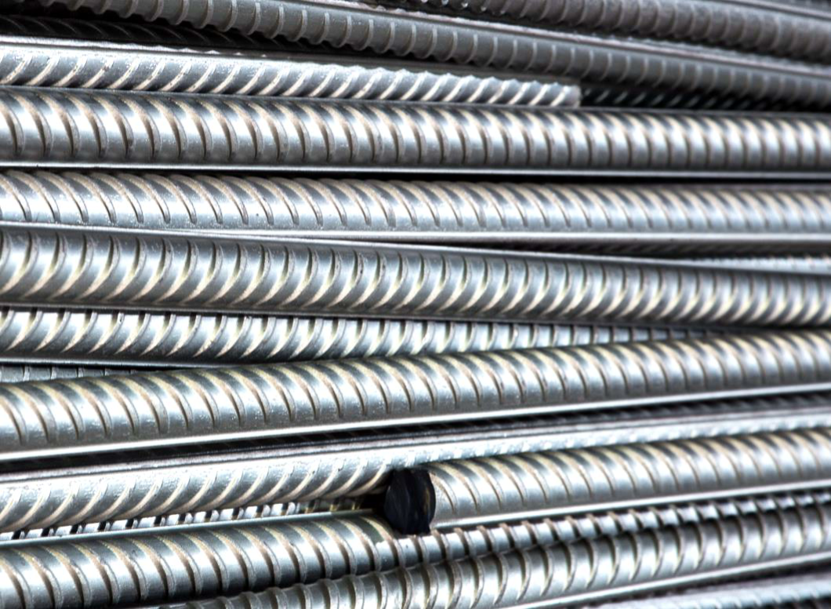

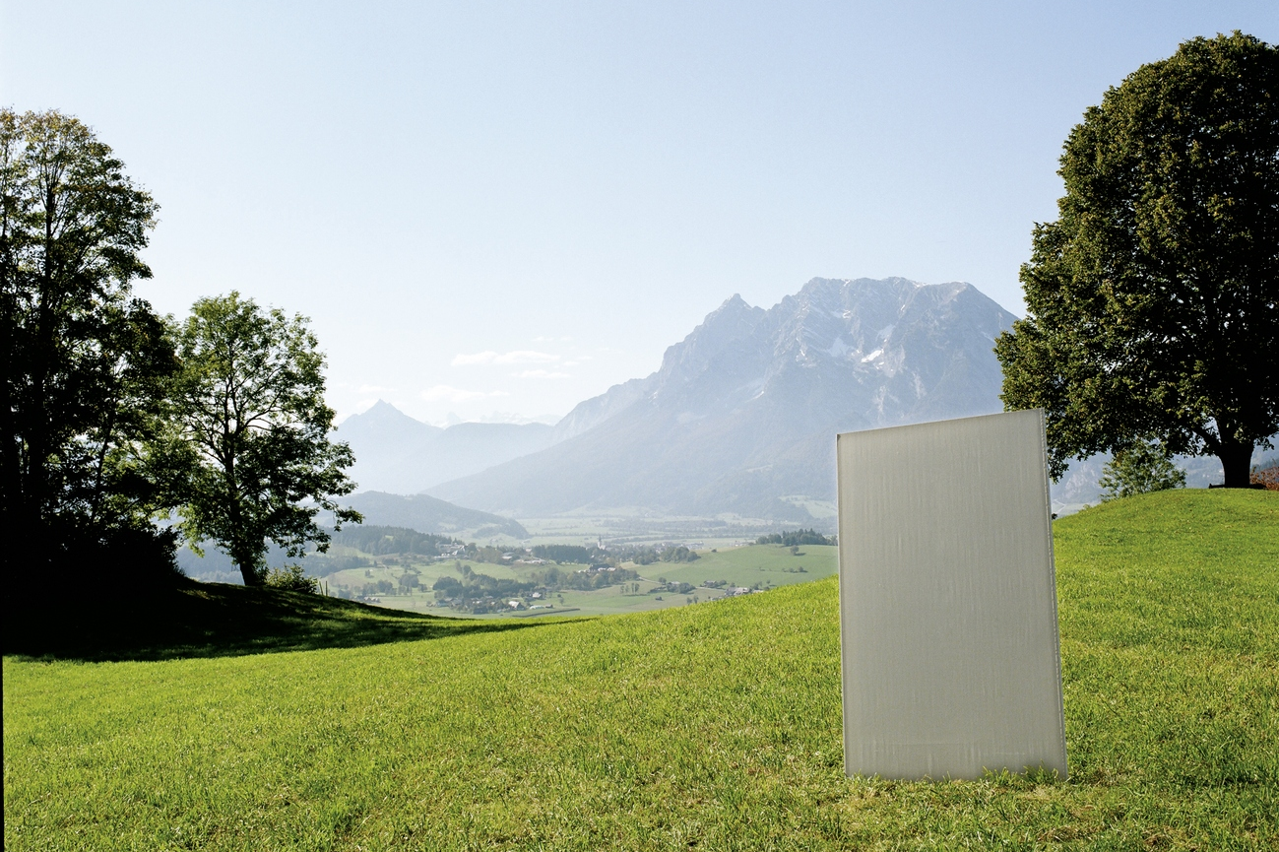

Imprint

Publisher:

Bau EPD GmbH

Seidengasse 13/3
A-1070 Vienna
Austria
http://www.bau-epd.at
office@bau-epd.at

© Bau EPD GmbH

Picture credits frontpage: www.trm.at

Tracking of versions

Version | Comments | Date of changes
1.0 | New structure following decisions of TAC from 2017-05-11, adaptations following resolutions from TAC in autumn 2016 and 2017. | 2017-08-17
2.0 | Changes following decisions of TAC since last publication. Changes on occasion of verification of PCR for concrete and concrete elements as well as resulting from working out the PCR for steel reinforcement. Changes to be made in all PCR B parts as well as some editorial chances. Index now included. | 2019-07-06
3.0 | Adaptation as per EN 15804:2019+A2:2019; adaptation of rules for declaration of geographical representativity | 2020-11-05
4.0 | Public version for interested parties after approval of PCR review panel. | 2021-01-12
5.0 | Consideration of comments, approval for EPD creation | 2021-04-07
6.0 | Adaptation tables module B and C, minor editorial changes | 2021-08-27
7.0 | Change ECO Platform logo, note to photographic rights, minor editorial changes (created by SR, checked by FG and approved by SR) | 2021-11-27
8.0 | Addition of accreditation mark, change owner, publisher, holder of declaration, specification of CF factors, editorial changes, title page EPD declaration of Energy Mix Approach,  (created by SR, checked by FG and approved by SR) | 2023-01-27

Contents

1. Scope 5
Requirements on the layout of the EPD 5
Content of the EPD 5
1. General information 7
2. Product 9
2.1 General product description 9
2.2 Application field 9
2.3 Standards, guidelines and regulations relevant for the product 9
2.4 Technical data 10
2.5 Basic/auxiliary materials 11
2.6 Production 12
2.7 Packaging 13
2.8 Conditions of delivery 14
2.9 Transport 14
2.10 Processing/ installation 14
2.11 Use stage 14
2.12 Reference service life (RSL) 14
2.13 Reuse and recycling 15
2.14 Disposal 15
2.15 Further information 15
3. LCA: Calculation rules 16
3.1 Declared unit/ Functional unit 16
3.2 System boundary 16
3.3 Flow chart of processes/stages in the life cycle 18
3.4 Estimations and assumptions 18
3.5 Cut-off criteria 18
3.6 Data sources 18
3.7 Data quality 18
3.8 Reporting period 18
3.9 Allocation 18
3.10 Comparability 18
4. LCA: Szenarios and additional technical information 19
4.1 A1-A3 product stage 19
4.2 A4-A5 Construction process stage 19
4.3 B1-B7 use stage 19
4.4 C1-C4 End-of-Life stage 21
4.5 D Potential of reuse and recycling 22
5. LCA: results 22
6. LCA: Interpretation 26
7. Literature 27
8. Directory and Glossary 27
8.1 List of figures 27
8.2 List of tables 27
8.3 Abbreviations 28

Scope
This document contains the Requirements on an Environmental Product Declaration (EPD) as per EN 15804 and ISO 14025 and requirements of Bau EPD GmbH.

The document applies to:
- Ductile cast iron piles (ÖNORM B 2567)
- Pipes, fittings, accessories made of ductile cast iron and their connections for water pipes (ÖNORM EN 545)
- Pipes, fittings, accessories made of ductile cast iron and their connections for sewage disposal (ÖNORM EN 598)
- Attachments and covers for traffic areas made of cast iron (ÖNORM EN 124-2, September 2015 edition) and ÖNORM B 5110, Part 1: Interchangeable tops and covers made of cast iron - Supplementary national provisions for ÖNORM EN 124-1 and -2, October 2015 edition and ÖNORM B 5110, Part 2: Non-exchangeable tops and covers made of cast iron - Supplementary national provisions for ÖNORM EN 124-1 and -2, October 2015 edition

The requirements on the EPD include:
- Requirements from EN ISO 14025
- Requirements on the EN 15804 standard as a European core EPD
- Complementary requirements on EPD of Bau EPD GmbH

The calculation rules for the Life Cycle Assessment and Requirements on the project report are specified in a separate document – “Management System Handbook chapter 5” of Bau EPD GmbH.

Requirements on the layout of the EPD
Bau-EPD GmbH determines the following features with regard to the layout of the EPD:

- The document on hand defines the format template for EPD-document that is to fill in (Word file „Format template EPD Bau EPD GmbH“, download at www.bau-epd.at).
- The content of an EPD is not limited in length of text.
- The layout of the front page of the EPD is defined and picture material must be accorded with Bau EPD GmbH (not more than 4 MB).
- On the last page of the EPD the publishing institution as well as the programme operator (Bau EPD GmbH in both cases), the LCA practitioner and owner of the declaration must be indicated with a logo and full address (including telephone number, fax number, email and website).
- Generally the font „Calibri“ must be used.
- In addition to the EPD as Microsoft Word format an Excel-document (BAU EPD M-DOCUMENT 8- excel-file for electronic data transfer Editor baubook ECO Platform) must be created including the result tables for electronic transfer and complying to EN 15942 (ITM Matrix). The templates of Bau EPD GmbH must be used, for these tables also serve to forward data to database owners (ECO Platform/ECO Portal, OEKOBAUDAT and BAUBOOK).

Content of the EPD
The following format template respective guidance describes the required structure of the EPD document including the required content for each individual chapter.
In addition to that, this document is giving specific notes for the creation of an EPD for cast iron building products and specific LCA calculation rules for cast iron building products that must be considered when creating the EPD and underlying LCA study.

Parts of the content that are considered as additional information of optional character (=not required as per international standard and/or guidelines from ECO Platform) are marked in lilac colour. This information is free to choose whether to declare or not and indications can be delivered by the owner of the declaration on optional basis.

Legend:
Blue: required content for each chapter
Turquoise: specific requirements for EPD of materials from the scope of the PCR
Green: specific LCA rules for EPD of material from the scope of the PCR
Violet: additional information of optional character

EPD - ENVIRONMENTAL PRODUCT DECLARATION

As per ISO 14025 and EN 15804
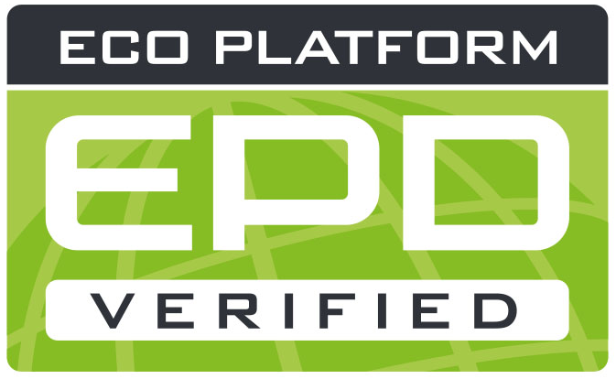
OWNER AND Publisher Bau EPD GmbH, A-1070 Wien, Seidengasse 13/3, www.bau-epd.at
Programme Operator Bau EPD GmbH, A-1070 Wien, Seidengasse 13/3, www.bau-epd.at
Holder of the Declaration Name of declaration holder
Declaration Number To be accorded with Bau EPD GmbH
Issue Date Date
Valid To Date
NUMBER OF DATASETS Number
ENERGY MIX APPROACH MARKET BASED APPROACH

Name and description of product
Name of declaration owner

picture
To be accorded with declaration owner and Bau EPD GmbH
(Note: photographic rights must be clarified and cited)

Company logo of declaration owner

Contents:

Content of the EPD 5
1. General information 7
2. Product 9
2.1 General product description 9
2.2 Application field 9
2.3 Standards, guidelines and regulations relevant for the product 9
2.4 Technical data 10
2.5 Basic/auxiliary materials 11
2.6 Production 12
2.7 Packaging 13
2.8 Conditions of delivery 14
2.9 Transport 14
2.10 Processing/ installation 14
2.11 Use stage 14
2.12 Reference service life (RSL) 14
2.13 Reuse and recycling 15
2.14 Disposal 15
2.15 Further information 15
3. LCA: Calculation rules 16
3.1 Declared unit/ Functional unit 16
3.2 System boundary 16
3.3 Flow chart of processes/stages in the life cycle 18
3.4 Estimations and assumptions 18
3.5 Cut-off criteria 18
3.6 Data sources 18
3.7 Data quality 18
3.8 Reporting period 18
3.9 Allocation 18
3.10 Comparability 18
4. LCA: Szenarios and additional technical information 19
4.1 A1-A3 product stage 19
4.2 A4-A5 Construction process stage 19
4.3 B1-B7 use stage 19
4.4 C1-C4 End-of-Life stage 21
4.5 D Potential of reuse and recycling 22
5. LCA: results 22
6. LCA: Interpretation 26
7. Literature 27
8. Directory and Glossary 27
8.1 List of figures 27
8.2 List of tables 27
8.3 Abbreviations 28

General information

Product name  Name and description of product | Declared Product / Declared Unit  Description of the declared product and declared unit/functional unit  Number of datasets in EPD Document(s): XX  Range of validity  The products considered in the data of the life cycle assessment and for which the declaration applies must be named.  In the case of an average EPD, this type of EPD must be pointed out.  The representativeness of the declaration must be shown with regard to the production volume covered by the life cycle assessment and the technology used. Likewise, the range of fluctuation of the product group considered, must be specified in the interpretation.
Declaration number
To be accorded with Bau EPD GmbH
Declaration data
Specific data
Average data

Declaration based on:
MS-HB version dated dd.mm.yyyy:
Name of PCR
PCR Code
Version
(PCR tested and approved by the independent expert committee
= PKR-Gremium)
The owner of the declaration is liable for the underlying information and evidence; Bau EPD GmbH is not liable with respect to manufacturer
information, life cycle assessment data and evidence.
Type of Declaration as per EN 15804  From cradle to ... .....  LCA-method: (i.e. Cut-off by classification) | Database, Software, Version  Declaration of backround database, Software used and both its versions  Version Characterisation Factors: Quelle, Version
Author of the Life Cycle Assessment  Name of the author  Institution, Address  website | The CEN standard EN 15804:2014+A1 serves as the core-PCR.  Independent verification of the declaration according to ISO 14025:2010  internally externally  Verifier 1: Name  Verifier 2: Name
Holder of the Declaration  Name of the manufacturer/owner  Institution, Address  website | Owner, Publisher and Programme Operator  Bau EPD GmbH  Seidengasse 13/3  1070 Vienna  Austria

DI (FH) DI DI Sarah Richter
Head of Conformity Assessment Body

Academic Title Name Academic Title Name,
Verifier Verifier

Note: EPDs from similar product groups from different programmes might not be comparable.

Product

General product description

For the product description the characteristics of the declared product must be described. In case of average EPD (“sector or branch” EPD) all declared products must be described separately.

Indications for the general product description:
- Separate description of products/materials for each product standard applicable, citing the product types and names.
- Description of characteristic components.
- All factory locations for the respective product categories must be declared, alternatively a reference can be made to an overview in an appendix (mandatory information in the project report, voluntary information in the EPD document)

Specific notes for the creation of an EPD for cast iron building products:

Explanation based on an example:
The declared product is e.g. a ductile iron pole with a diameter of 118 mm, a wall thickness of 10.6 mm and a length of 1 m.

Application field

The use and application purpose of the named products are to specify. The individual applications (including functions) must be declared as a text or table format.
Specific notes for the creation of an EPD for cast iron building products:
None.

Standards, guidelines and regulations relevant for the product

The respective standard and/or general technical approval or comparable national regulation can be indicated.

Optional: Documentation under the frame of CE -certification such as certificates of constancy of performance, certificates of conformity of the internal production control on the manufacturer’s site, Declarations of performance, Official certificates of registration, European Technical Assessments or Technical permissions of construction industry can be cited.

Specific notes for the creation of an EPD for cast iron building products:
The standards regulating cast iron building products must be cited (i.e. standards, guidelines, other regulations)
Examples for product standards for cast iron building products in Austria are illustrated in table 1.

Table 1: Product specific standards
Standard | Title
ÖNORM B 2567 | Ductile iron piles
ÖNORM EN 545 | Ductile iron pipes, fittings, fittings and their joints for water supply
ÖNORM EN 598 | Ductile iron pipes, fittings, accessories and their connections for sewage disposal
ÖNORM EN 124-2, Ausgabe September 2015 | Cast iron tops and covers for traffic areas
ÖNORM B 5110, Teil 1, Ausgabe Oktober 2015 | Replaceable tops and covers made of cast iron - Supplementary national regulations to ÖNORMEN EN 124-1 and -2
ÖNORM B 5110, Teil 2, Ausgabe Oktober 2015 | Non-exchangeable tops and covers made of cast iron - Supplementary national regulations to ÖNORMEN EN 124-1 and -2

Technical data

For products carrying a CE marking as per Construction Products Regulation (CPR) the EPD must declare at least the same technical data as required and indicated in the declaration of performance of the manufacturer. What kind of data is required in each individual case is to learn from the document underlying the CE marking: any Harmonized European Standard or European Technical Assessment (ETA).
Additional technical data must be listed if relevant for product distinction or specification.

Specific notes for the creation of an EPD for cast iron building products:
The (construction) technical data listed in Table 2 to Table 4 are based on the national standards or the harmonized European product standards for construction products made of cast iron (see scope) and must be specified with reference to the test standard. An indication in the different categories is only to be made if these are relevant for the declared product according to the product standard (see footnotes).

Table 2: Technical data for ductile iron piles
Designation | Value | Unit
Density cast iron | Value | kg/m³
tensile strength | Value | MPa
Proportional limit, 0.2% proof stress | Value | MPa
elongation at break | Value | %
impact work | Value | J
Brinell hardness | Value | HB
compressive strength | Value | MPa
Modulus of elasticity E | Value | MPa
outer diameter | Value | mm
wall diameter | Value | mm
pile tube length | Value | mm
mass per running meter | Value | kg/m
Design value of the normal load-bearing capacity NSd without concrete filling and grouting (no loss of wall thickness) | Value | kN

Table 3: Specifications for Ductile Iron Pipes, Fittings, Accessories
Designation | Value | Unit
Density cast iron | Value | kg/m³
tensile strength | Value | MPa
Proportional limit, 0.2% proof stress | Value | MPa
elongation at break | Value | %
impact work | Value | HB
Brinell hardness | Value | MPa
compressive strength | Value | MPa
Modulus of elasticity E | Value | MPa
outer diameter | Value | mm
wall diameter | Value | mm
pile tube length | Value | mm
mass per running meter | Value | kg/m
Design value of the normal load-bearing capacity NSd without concrete filling and grouting (no loss of wall thickness) | Value | bar

Table 4: Technical data for tops and covers for cast iron traffic areas

The technical data listed in the declaration of performance are to be adopted here in tabular form.

For specific EPD the technical data of the product must be declared as required in Table 2 to Table 4.
For average EPD (“Sector or Branch-EPD“, “Group EPD” or “EPD from Associations”) Table 2 must be filled, average values or ranges are accepted, in addition a note stating „see product sheets“ pointing to single technical product sheets can be cited. Technical data must be provided by the manufacturers. The manufacturers are to ensure that the relevant data are accessible, and the LCA-practitioner must indicate the sources where the technical data can be downloaded.
In this case the average value of nominal density/ weight per m² used for calculating the LCA must be declared as an additional information in chapter 3.1.

Basic/auxiliary materials

The product components and/or contents and ingredients must be declared in mass-% to enable the user of the EPD to understand the composition and structure of the product in delivery status. These indications shall also support security and efficiency in installation, use and disposal of the product.

The declaration of mass-% can be accurate numbers or a range by analogy with REACH . The mass of components that make up less than 1 mass-% of the total product mass can be declared with < 1 mass-%.

The declaration of material product content must list at least those substances contained in the product which are included in the “Candidate List of Substances of Very High Concern for Authorization” where their contents exceed the limit values (0.1 mass-% on product level) for registration by the European Chemicals Agency (ECHA). If substances and preparations lose their hazardous features during manufacturing (e.g. after a complete chemical reaction) they are exempted from the obligation of declaration.
If the content of the material is below the limit of ECHA the following note must be stated in the EPD:
„The content of XXXX is below the limit values of the registration by the European Chemicals Agency (ECHA). Interpreting statements such as “… free of …” or “… are entirely harmless …” are not permissible.

The product components must be described in detail, so that their sort of product is clear, but the protection of sensitive data is assured, and company secrets are not revealed.
For additives, the function and substance class respective chemical group (i.e. hydraulic binders) must be stated. In addition to that all auxiliary materials and additives that stay within the product must be declared.

Specific notes for the creation of an EPD for cast iron building products:
Basic materials are to be listed according to Table 3, auxiliary materials are to be listed separately.

Table 5: base materials in mass-% (example)
Bestandteile: | Massen %
iron 1) | 94%
carbon 2) | 3,5%
silicon 3) | Ca. 2%
iron accompanying elements x) | 0,5%
component E x)
...

^{x)} Optional: footnote with description for each component

x) Optional: Footnote for each component with a brief explanation of the substance and raw material extraction (recycling, etc.)
1) Scrap iron, or iron ore, is melted in the furnace
2) Graphite or carbide carbon from foundry coke, blast furnace coke, petroleum coke or other carbon carriers depending on how the products are made
3) Silicon as an alloying element made of ferro-silicon, silicon carbide or other silicon carriers, specification of other alloying elements such as manganese, chromium, nickel, etc. depending on the type of manufacture of the products
4) common accompanying elements of steel scrap
Auxiliaries / additives
Specifications and proportions of excipients are to be stated (in text or tabular format)

Production

The process of production must be described and illustrated with a simple figure (i.e. flow chart). In case of average EPD the production processes of all sites must be described respective a useful summary must be included and a list of all production sites must be provided in an annex. Quality management systems, eco management systems etc. can be referred to.

Specific notes for the creation of an EPD for cast iron building products:
Example:
The cast iron is melted. The melt must then be alloyed for the final analysis. The addition of Mg is essential for this (ductile cast iron). The liquid metal is cast into a solid form in a casting machine. After unpacking from the mold, the product is cooled and, depending on the metallurgical composition, heat-treated on a case-by-case basis. Finally, the product is mechanically processed to obtain its final shape.

Figure 1: Example of a flow chart/graphic production stage
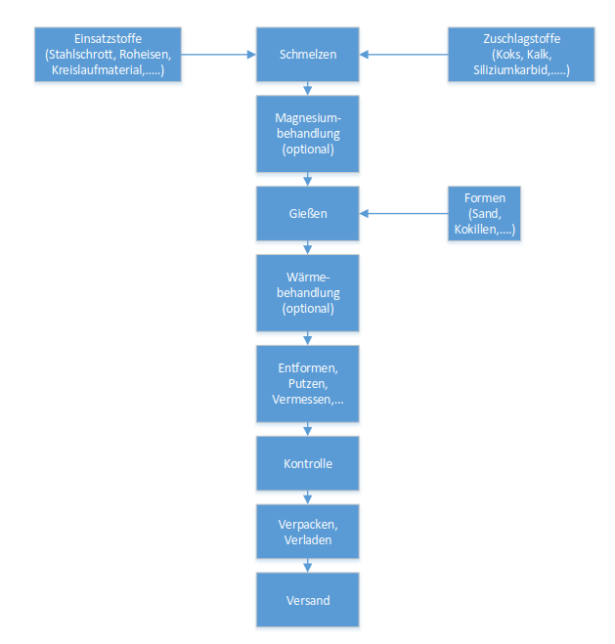

Legend:

Einsatzstoffe (Stahlschrott, Roheisen, Kreislaufmaterial) | Input materials (steel scrap, pig iron, return material)
Zuschlagstoffe (Koks, Kalk, Siliziumkarbid) | Aggregates (coke, lime, silicon carbide)
Magnesiumbehandlung (optional) | Magnesium treatment (optional)
Gießen | to water
Formen (Sand, Kokillen) | molds (sand, moulds)
Wärmebehandlung (optional) | heat treatment (optional)
Entformen, Putzen, Vermessen | Demoulding, cleaning, measuring
Kontrolle | control
Verpacken, Verladen | packing, loading
Versand | shipment

Description of chart

Packaging

Information concerning each component of packages:

Type (Foil, pallets, etc.),
Material (Paper, Polyethylene; including origin, e.g. recycled paper) and
Possibilities of reuse (e.g. multi way pallets).

Specific notes for the creation of an EPD for cast iron building products:
Example: As a rule, cast iron building products is delivered loose (without packaging material) but sometimes with squared timber as a stacking aid and with steel wire fastening straps for bundling.

Conditions of delivery

Written description of conditions of delivery, units of delivery, size and dimension as well as requirements on storage important for the declared product(s).

Transport

Description of delivery (Route and means of transport).

Processing/ installation

Description of way of treatment, used machines, tools, dust collection etc., auxiliary materials as well as measures of noise reduction. Notes regarding recognized rules of engineering, work safety or protection of the environment can be included.
References to detailed processing directives and referrals to user safety (safe use instruction sheets) of the manufacturer are required.

Specific notes for the creation of an EPD for cast iron building products:
The installation or incorporation of construction products made of cast iron depends to a large extent on the planned application (pile foundation, water supply, sewage disposal) and the respective product characteristics.

In the case of piles made of ductile cast iron, the description of the installation must explicitly define whether they are unfilled or uninjected piles or piles with concrete filling and/or jacket injection. Depending on the design variant, the additional construction processes (for concrete filling or grouting) must be taken into account in the EPD.

With regard to pipes for water pipes or sewers, the installation process, including digging or the production of cuvettes, does not necessarily have to be taken into account. If this is taken into account, it must be described transparently. In addition, a reference to the dependency of the environmental impact during installation, to accessibility, to the applicable device, the soil conditions, etc. must be given.

Use stage

Notes describing specific features of the material composition relevant for the use stage.

Specific notes for the creation of an EPD for cast iron building products:
In the case of building products made of ductile cast iron, there are no changes in the material composition over the period of use if they are properly planned, properly and professionally installed and used without problems.

Reference service life (RSL)

The indication of the reference service life (RSL) is imperative for EPDs covering the complete use stage (modules B1-B7), or if a use stage scenario is described, which refers to the lifetime of the product (“from cradle to grave”).
The RSL must refer to the declared technical and functional quality of the product. It must be established in line with all of the specific rules in the European product standards and must also take consideration of the ISO 15686-1, -2, -7 and -8 standards.
Where information is available for deriving the RSL from harmonized European product standards, such data has priority.
The assumption underlying the calculation of the RSL and for those only the RSL can be declared must be stated. Influence on aging as per recognized rules of engineering.

Table 6: Reference service life (RSL)
Characterization | value | unit
Ductile iron piles | 100 ^{a)} | years
Ductile iron pipes | 100 ^{b)} | years
Reference conditions on which the RSL is based (if relevant) |  | Individual units

a) Pile foundations must have a service life that corresponds to the structure as a whole. According to "Eurocode - Basis of structural design (ÖNORM EN 1990)", engineering structures (e.g. bridges) have a service life of 100 years, which is why a corresponding RSL is applied here for piles made of ductile cast iron.
b) Ductile iron pipes, fittings and accessories for water supply and sewage disposal can be coated or lined with a wide variety of materials. The RSL of the pipe variants depends heavily on the casing and the lining, but also to a large extent on the handling of the bedding and the installation conditions. With the correct selection of the material used and proper installation, actual service lives of more than 100 years can be achieved (see e.g. also study by the European Association for Ductile Iron Pipe Systems)

See EN 15804+A2 clause 6.3.4 and Annex A requirements and guidelines for reference service life

If no reference service life can be determined according to the rules of EN 15804+A2 (Annex A), a default value from a complementary PCR of the CEN/TC product committees, if available, must be used. If no complementary PKR is available, the service life can be declared from service life catalogues, depending on the area of ​​application, stating the source, e.g. according to BAU EPD-M-DOKUMENT-20-Reference-usage-times-20150810 (Austria) or the BBSR table "Useful lives of components on life cycle analysis according to BNB” (Germany). If no information can be found there, the RSL can be derived from other sets of regulations (Eurocodes, other basis).

Reuse and recycling

Possibilities and scenarios of reuse and recycling must be described.

Disposal

The different ways of disposal must be described.
The EAK-waste disposal code (Disposal code following the European list of waste) must be declared.

Further information

Optional details, indication of reference source for additional information, e.g. websites…

LCA: Calculation rules

Declared unit/ Functional unit

The declared resp. functional unit, the mass reference and the conversion factor to 1 kg must be declared in a table.

Specific LCA calculation rules for cast iron building products:
The declared unit for building products made of ductile cast iron is 1 t. The average gross density of the cast iron and the mass per running meter of product must be specified. Other declared units are permitted if the conversion to 1 t is shown transparently.
Table 7: Declared unit 1 t
characterization | value | unit
Declared unit | 1 | t
Bulk density cast iron |  | kg/m³
Linear mass |  | Kg/m
Nominal wall thickness |  | mm

A functional unit can be specified for construction products made of ductile cast iron if the function of the declared products can be clearly described. This is possible, for example, for poles, water pipes or sewage pipes, where the functional unit can be defined as a 1 m pole or pipe.
If average results of different products are declared, the methods of calculating the average values must be explained.
In this case the average value of nominal density/ weight per unit used for calculating the LCA must be declared as an additional information.

System boundary

The type of EPD with regard to the applied system boundaries must be specified in the EPD. All building products and materials must declare modules A1-A3, modules C1-C4 and module D. The following EPD types may be specified:
• from the cradle to the factory gate with modules C1-C4 and module D (A1-A3 + C + D);
• from the cradle to the factory gate with options, modules A1-A3, C1-C4 and D (A1-A3 + C + D and additional modules. The additional modules may be one or more modules selected from A4 to B7);
• from cradle to grave and module D (A + B + C + D)
Exceptions to this rule are specified in EN 15804+A2, chapter 5.2.
Note: The specifications for the modules that must be declared no longer correspond to ÖNORM EN 16783:2017 - the specifications from EN 15804:2019+A2 apply primarily.
All declared life cycle stages (modules) are to be marked with an "X" in Table 7. Undeclared modules are to be marked with ND (= not declared).

Table 8: Declared life cycle stages
PRODUCT STAGE |  |  | CON-STRUCTION PROCESS STAGE |  | USE STAGE |  |  |  |  |  |  | END-OF-LIFE STAGE |  |  |  | BENEFITS  AND LOADS BEYOND THE SYSTEM BOUNDARIES
A1 | A2 | A3 | A4 | A5 | B1 | B2 | B3 | B4 | B5 | B6 | B7 | C1 | C2 | C3 | C4 | D
Raw material supply | Transport | Manufacturing | Transport from the gate  to the site | Construction, installation | Use | Maintenance | Repair | Replacement | Refurbishment | Operational energy use | Operational water use | De-construction, demolition | Transport | Waste processing | Disposal | Reuse-  Recovery-  Recycling-  potential
x | x | x | x | x | x | x | x | x | x | x | x | x | x | x | x | x
X = included in LCA; MND = Module not declared
The modules assessed in the LCA study must be described shortly. It should be made apparent, which processes are calculated in which module and how the system boundaries to nature resp. to other product systems are set (if relevant for the declared product).

If not all modules are declared in an EPD, a clear justification must be given.

Specific LCA calculation rules for cast iron building products:
A1-A3:
In the manufacturing phase, all materials, products and energies (including energy export) as well as any waste and its treatment or disposal must be taken into account. Modules A1, A2 and A3 can be evaluated and presented in aggregated form.
A4-A5:
Ductile iron piles can be designed as unfilled or ungrouted piles or piles with concrete filling and/or grouting. Depending on the design variant, the additional construction processes (for concrete filling or compression) must be taken into account in the life cycle assessment.
With regard to pipes for water pipes or sewers, the installation process, including digging or the production of cuvettes, does not necessarily have to be taken into account. If this is considered, the scenario used must be described transparently. In addition, a reference to the dependence of the environmental impact during installation on accessibility, the applicable device, the soil conditions, etc. must be given.
B1-B7:
As a rule, no LCA-relevant processes occur with building products made of ductile cast iron over the period of use.
C1 - C4 and D:
In principle, dismantled construction products made of ductile cast iron can be fed into a recycling process. Module D shows the substitution of primary raw materials by the removed cast iron in the course of the production of additional cast iron. The secondary material content of the cast iron specified according to the EN 15804 method must be taken into account.

In the case of piles made of ductile cast iron, depending on the given situation, the question arises as to whether an expansion should be carried out or whether it makes sense to do so. If no new structure is erected after the entire structure has been dismantled, the piles are left in the ground if they do not obstruct anything there and additional costs can thus be avoided.
In the case of balancing the concrete filling / jacket grouting, a realistic end-of-life utilization scenario must be selected. The recycling of the concrete filling/jacket grouting may have to be shown separately from the recycling of the cast iron.

Flow chart of processes/stages in the life cycle

A meaningful flow chart describing the manufacturing process shall give further aid to comprehension. The flow chart must be subdivided at least into the phases of life cycle declared (production, use, end-of-life). The phases can be partitioned into appropriate process stages.

Estimations and assumptions

The assumptions and assessments that are important for the interpretation of the life cycle assessment are to be listed here.

Cut-off criteria

The application of the cut-off criteria according to MS-HB Chapter 5.5.3 must be documented here.

Data sources

The quality of the collected data must be described.

Data quality

The sources of the backround data sets must be declared. If necessary, additional information on the quality of the used data sets shall be made (estimations). The issuing year of the used data material must be indicated.

Reporting period

The period under review must be documented (in case of average EPD this would be the basis of the calculated average).

Allocation

The allocations of relevance for calculation (appropriation of expenses across various products) must be indicated, at least:
- System boundary settings/allocation in the use of recycled and/or secondary raw materials
- Allocation concerning co-products
- Allocation of energy, auxiliary and operating materials used for individual products in a factory
- Loads and credits from recycling or energy recovery of packaging materials and production waste
- Loads and credits from recycling or energy recovery from the end of life of the product

whereby reference must be made to the modules in which the allocations are performed.
Detailed regulations concerning calculation of secondary materials and allocation MS-HB chapter “LCA rules” apply in all studies.

Comparability

With reference to comparability of EPD data the following facts must be mentioned:

Comparison or benchmarking of EPD data is only possible, if all compared data sets are calculating following EN 15804 in the same version, the same programme specific PCR-rules or other additional rules. The same backround data sources and software versions must be applied. Moreover, the context of the function in the building or product specific features of performance must be considered.

LCA: Scenarios and additional technical information

The following information is mandatory to give for all declared modules, for modules not declared it is optional. If need, additional information can be declared.

A1-A3 product stage

Following EN 15804 no scenario documentation is required for A1-A3 for the declaration and calculation of these modules lies within the responsibility of the manufacturer and must not be altered by the LCA practitioner.
Note: the masses of packaging per declared unit must be indicated, this is especially important if A5 is not declared.

A4-A5 Construction process stage

Table 9 and the units listed must be used for calculation the environmental impact of the transport phase.
Table 10 and the units listed must be used for calculation the environmental impact of the installation into the building.

Table 9: Description of the scenario „Transport to building site (A4)“
Parameters to describe the transport to the building site (A4) | Quantity per unit
Average transport distance | km
vehicle type, Commission Directive 2007/37/EC (European Emission Standard) | -
Fuel type and average consumption of vehicle | l/100 km
Maximum transport mass | tons
Capacity utilisation (including empty returns) | %
Bulk density of transported products | kg/m³
Volume capacity utilisation factor (factor: =1 or <1 or ≥ 1 for compressed or nested packaged products) | -
^{x)} The table must be filled with reference to the information available from the datasets used (i.e. in case of transport by ship). The datasets used must be noted in a footnote.

Table 10: Description of the scenario „Installation of the product in the building (A5)“ as per table 8 in ÖNORM EN 15804
Parameters to describe the installation of the product in the building (A5) | Quantity per unit
Ancillary materials for installation (specified by material); | Meaningful unit
Water use | m³
Other resource use | kg
Electricity demand | kWh or MJ
Other energy carrier(s): ……………. | kWh or other unit (e.g. litres)
Wastage of materials on the building site before waste processing, generated by the product’s installation (specified by type) | kg
Output materials (specified by type) as result of waste processing at the building site e.g. of collection for recycling, for energy recovery, disposal (specified by route) | kg
Direct emissions to ambient air, soil and water | kg

B1-B7 use stage

Reference Service life: [a]
The parameters and the units listed in the following tables must be used for calculation the environmental impact of the use stage (B2-B7). The tables can be excluded if no input or output happens. In this case a note of explanation would be sufficient: “In module BX-BY no material resp. mass flows occur, input +/- output = 0

Table 11: Description of the scenario „maintenance (B2)“ based on table 9 in EN 15804
Parameters maintenance (B2) | value | unit
Maintenance process |  | Description or source where description can be  found
Maintenance cycle |  | Number per RSL or year ª
Ancillary materials for maintenance, e.g.  cleaning agent, specify materials |  | Kg/cycle
Waste material resulting from maintenance (specify materials) |  | kg
Net fresh water consumption during maintenance |  | m³
Energy input during maintenance, e.g. vacuum cleaning, energy carrier type, e.g. electricity, and amount, if applicable and relevant |  | kWh

Table 12: Description of the scenario „repair (B3)“
Parameters repair (B3) | value | unit
Repair process |  | Description or source where description can be  found
Inspection process |  | Description or source where description can be  found
Repair cycle |  | Number per RSL or year
Ancillary materials, e.g. lubricant, specify  materials |  | Kg or kg/cycle
Waste material resulting from repair, (specify materials) |  | kg
Net fresh water consumption during repair |  | m³
Energy input during repair, e.g. crane activity,  energy carrier type, e.g. electricity, and amount |  | kWh

Table 13: Description of scenario „replacement (B4)“
Parameters replacement (B4) | value | unit
Replacement cycle |  | Number per RSL or year
Energy input during replacement e.g. crane  activity, energy carrier type, e.g. electricity and  amount if applicable and relevant |  | kWh
Exchange of worn parts during the product’s life cycle, e.g. zinc galvanised steel sheet, specify materials |  | kg

Table 14: Description of scenario „refurbishment (B5)“

Parameters refurbishment (B5) | value | unit
Refurbishment process |  | Description or source where description can be  found
Refurbishment cycle |  | Number per RSL or year
Energy input during refurbishment e.g. crane  activity, energy carrier type, e.g. electricity, and  amount if applicable and relevant |  | kWh
Material input for refurbishment, e.g. bricks, including ancillary materials for the refurbishment process e.g. lubricant, (specify materials) |  | kg or kg / cycle
Waste material resulting from refurbishment (specify materials) |  | kg
Further assumptions for scenario development, e.g. frequency and time period of use, number of occupants |  | Units as appropriate

Table 15: Description of scenarios „energy (B6)“ resp. „Water (B7)“
Parameters energy (B6) and water (B7) | value | unit
Ancillary materials, e.g. lubricant, specify  materials |  | Kg or kg/cycle
Net fresh water consumption |  | m³
Type of energy carrier, e.g. electricity, natural gas, district  heating |  | kWh or m³
Power output of equipment |  | kW
Characteristic performance, e.g. energy efficiency, emissions, variation of performance with capacity utilisation etc. |  | units as appropriate
Further assumptions for scenario development, e.g. frequency and period of use, number of occupants |  | units as appropriate
Specific LCA calculation rules for cast iron building products:
In the use phase (B1), there are no material and energy flows relevant to the life cycle assessment for building products made of ductile cast iron (i.e. the results for B1 are to be set at "zero").

During use, no maintenance, repair, replacement or conversion processes take place for building products made of ductile cast iron, which is why modules B2 to B5 cause no environmental impact (i.e. the results for B2 are to be set at "zero"). Modules B6 and B7 are not relevant for construction products made of ductile cast iron, which means that there is no environmental impact either (B6 and B7 are to be declared with "0").

C1-C4 End-of-Life stage

Short description of processes concerning disposal and scenarios going with that (i.e. for transport).

Specific LCA calculation rules for cast iron building products:
In principle, dismantled building products made of cast iron are fed into a recycling process.

Table 16: Description of the scenario „Disposal of the product (C1 to C4)“ according to table 12 in EN 15804
Parameters for End-of-Life stage (C1-C4) | value | Quantity per m³ insulation material
Collection process specified by type |  | kg _{collected separately}
 |  | kg collected with mixed construction waste
Recovery system specified by type |  | kg _{for re-use}
 |  | kg _{for recycling}
 |  | kg _{for energy recovery}
Disposal specified by type |  | kg product or material for final deposition
Assumptions for scenario development, e.g. transportation |  | Appropriate units

D Potential of reuse and recycling

Short description of assumptions for reuse-, recover- and recycling processes.

Specific LCA calculation rules for cast iron building products:

The substitution of primary raw materials, taking into account the secondary material content of the cast iron removed in C1, is shown in Module D (net flow).
Table 17: Description of the scenario „re-use, recovery and recycling potential (module D)“
(Substituted primary materials resp. technologies must be declared in a separate footnote (including technical information).
Parameters for module D | value | unit
Materials for reuse, recovery or recycling from A4-A5 |  | %
Energy recovery or secondary fuels from A4-A5 |  | MJ/t resp. kg/t
Materials for reuse, recovery or recycling from B2-B5 |  | %
Energy recovery or secondary fuels from B2-B5 |  | MJ/t resp. kg/t
Materials for reuse, recovery or recycling from C1-C4 |  | %
Energy recovery or secondary fuels from C1-C4 |  | MJ/t resp. kg/t

LCA: results
The declaration of environmental indicators must be listed in the following tables with reference only to the declared life cycle stages. Indicator values should be declared with three valid digits (eventually exponential form (e.g. 1.23E-5 = 0.0000123). A uniform format should be used for all values of one indicator. It is preferred that the definitions of the environmental indicators are spelled out completely to ensure the best possible readability. If space is needed in case of too many columns the defined abbreviations are accepted.

Table 18: Parameters to describe the environmental impact of mineral insulating products per declared/functional unit
Para-meter | unit | A1-A3 | A4 | A5 | B1 | B2 | B5 | B6 | B7 | C1 | C2 | C3 | C4 | D
GWP total | kg CO₂ eq.
GWP fossil fuels | kg CO₂ eq.
GWP biogenic | kg CO₂ eq.
GWP luluc | kg CO₂ eq.
ODP | kg CFC-11 eq.
AP | mol H⁺ eq.
EP freshwater | kg PO₄³⁻ eq.
EP marine | kg N eq.
EP terrestrial | mol N eq.
POCP | kg NMVOC eq.
ADPE | kg Sb eq.
ADPF | MJ H_{u}
WDP | m3 Welt eq. entz.
Legende |  | GWP = Global warming potential; luluc = land use and land use change;  ODP = Depletion potential of the stratospheric ozone layer;  AP = Acidification potential, Accumulated Exceedance; EP = Eutrophierungspotenzial;  EP = Eutrophication potential; POCP = Formation potential of tropospheric ozone photochemical oxidants;  ADPE = Abiotic depletion potential for non-fossil resources; ADPF = Abiotic depletion potential for fossil resources WDP = Water (user) deprivation potential, deprivation-weighted water consumption

Table 19: Additional environmental indicators
Parameter | Unit | A1-A3 | A4 | A5 | B1 | B2 | B5 | B6 | B7 | C1 | C2 | C3 | C4 | D
PM | disease incidence
IRP | kBq U235 eq.
ETP-fw | CTUe
HTP-c | CTUh
HTP-nc | CTUh
SQP | dimension-less
Legende |  | PM = Potential incidence of disease due to Particulate Matter emissions; IRP = Potential Human exposure efficiency  relative to U235; ETP-fw = Potential Comparative Toxic Unit for ecosystems; HTP-c = Potential Comparative Toxic Unit for humans – cancer effect; HTP-nc = Potential Comparative Toxic Unit for humans – non-cancer effect; SQP = Potential soil quality index

Table 20: Parameters to describe the use of resources of mineral insulating products per declared/functional unit
Para-meter | unit | A1-A3 | A4 | A5 | B1 | B2 | B5 | B6 | B7 | C1 | C2 | C3 | C4 | D
PERE | MJ, net calorific value
PERM | MJ, net calorific value
PERT | MJ, net calorific value
PENRE | MJ, net calorific value
PENRM | MJ, net calorific value
PENRT | MJ, net calorific value
SM | kg
RSF | MJ, net calorific value
NRSF | MJ, net calorific value
FW | m³
Legend |  | PERE = Renewable primary energy as energy carrier; PERM = Renewable primary energy resources as material utilization; PERT = Total use of renewable primary energy resources; PENRE = Non-renewable primary energy as energy carrier; PENRM = Non-renewable primary energy as material utilization; PENRT = Total use of non-renewable primary energy resources; SM = Use of secondary material;  RSF = Use of renewable secondary fuels; NRSF = Use of non-renewable secondary fuels;  FW = Use of fresh water

contains restrictions that must be declared according to the following classification in the project report and in the EPD with regard to the declaration of relevant core and additional environmental impact indicators.

Table 21 contains restrictions that must be declared according to the following classification in the project report and in the EPD with regard to the declaration of relevant core and additional environmental impact indicators.

Table 21: Classification of disclaimers to the declaration of core and additional environmental impact indicators
ILCD-classification | Indicator | Disclaimer
ILCD-Type 1 | GWP Global Warming Potential | none
 | ODP Ozone Depletion Potential | none
 | PM Particulate Matter | none
ILCD-Type 2 | Acidification potential, Accumulated Exceedance (AP) | none
 | Eutrophication potential, Fraction of nutrients reaching  freshwater end compartment (EP-freshwater) | none
 | Eutrophication potential, Fraction of nutrients reaching  marine end compartment (EP-marine) | none
 | Eutrophication potential, Accumulated Exceedance  (EP-terrestrial) | none
 | Formation potential of tropospheric ozone (POCP) | none
 | Potential Human exposure efficiency relative to U235 (IRP) | 1
ILCD-Type 3 | Abiotic depletion potential for non-fossil resources  (ADP-minerals&metals) | 2
 | Abiotic depletion potential for fossil resources (ADP-fossil) | 2
 | Water (user) deprivation potential, deprivation-weighted  water consumption (WDP) | 2
 | Potential Comparative Toxic Unit for ecosystems (ETP-fw) | 2
 | Potential Comparative Toxic Unit for humans (HTP-c) | 2
 | Potential Comparative Toxic Unit for humans (HTP-nc) | 2
 | Potential Soil quality index (SQP) | 2
Disclaimer 1 – This impact category deals mainly with the eventual impact of low dose ionizing radiation on human health of the nuclear fuel cycle. It does not consider effects due to possible nuclear accidents, occupational exposure nor due to radioactive waste disposal in underground
facilities. Potential ionizing radiation from the soil, from radon and from some construction materials
is also not measured by this indicator.
Disclaimer 2 – The results of this environmental impact indicator shall be used with care as the
uncertainties on these results are high or as there is limited experienced with the indicator.

Table 22: Parameters describing LCA-output flows and waste categories of mineral insulating products per declared/functional unit
Para-meter | unit | A1-A3 | A4 | A5 | B1 | B2 | B5 | B6 | B7 | C1 | C2 | C3 | C4 | D
HWD | kg
NHWD | kg
RWD | kg
CRU | kg
MFR | kg
MER | kg
EEE | MJ
EET | MJ
Legend |  | HWD = Hazardous waste disposed; NHWD = Non-hazardous waste disposed; RWD = Radioactive waste disposed;  CRU = Components for re-use; MFR = Materials for recycling; MER = Materials for energy recovery; EEE = Exported electric energy; EET = Exported thermal energy

Table 23: Information for description biogenic carbon content at factory gate
Biogenic carbon content | unit
Biogenic carbon content in the product | kg C
Biogenic carbon content of packing | kg C
Note: 1 kg biogenic carbon is equivalent to 44/12 kg CO₂

If the mass of biogenic carbon containing materials in the product is less than 5 % of the mass of the
product, the declaration of biogenic carbon content may be omitted.
If the mass of biogenic carbon containing materials in the packaging is less than 5 % of the total mass of
the packaging, the declaration of the biogenic carbon content of the packaging may be omitted.

LCA: Interpretation

For better understanding of the LCA, the aggregated indicators of the inventory analysis as well as those of the impact assessment (LCIA) from chapter 5 must be interpreted in a dominance analysis. The interpretation must describe a range resp. variance of LCIA results, if the EPD is valid for more than one product.

It is recommended to illustrate the results with graphic elements (i.e. the dominance analysis showing distribution of environmental impacts over several modules…)

When declaring average products, the range of possible results for the individual products for the main impact categories that are relevant to the materials used must be specified.

As for module D, the interpretation must declare, that the benefits and loads lie beyond the system boundary. Any graphic elements showing result interpretation of the life cycle must be created in a way, that modules A1-C4 and module D are displayed separate picture elements. Alternatively, the results can be interpreted without graphic elements.

Extension of an EPD:
It is mandatory to declare in a separate block in the project report:
Reasons for deviations of results of single indicators of more than 15% compared to the results before. This serves as an information for verifiers and enhances legal compliance. Users of the data can be informed of such facts.
Claims that can be published (i.e. same framework conditions, different electricity mix) can be declared in the EPD, if desired.

Literature

Relevant standards and sources for the preparation of the EPD resp. for the definition of the product must be listed here. The full documentation of references is to be done as follows:

Author, First name. and Author, First name. (year). Title of article. subtitle. location: publishing company.
Author, First name. (year). Title of article. In: Surname, First name. and Surname, First name. (Publishing company): Name of paper. Bd. 2 or year number, 207-210.
Organisation (Year): Full name of standard or rule. Date of Issue. Location. Legal institution.
Always to be quoted:

ÖNORM EN ISO 14040 Environmental management - Life cycle assessment -- Principles and framework

ÖNORM EN ISO 14044 Environmental management - Life cycle assessment -- Requirements and guidelines

ÖNORM EN ISO 14025 Environmental labels and declarations -Type III environmental declarations -- Principles and procedures

ÖNORM EN 15804 Sustainability of construction works - environmental product declarations. Core rules for the product category of construction products

Management system handbook including applicable documents from Bau EPD GmbH

Directory and Glossary

List of figures

Figure 1: Example of a flow chart/graphic production stage 12

List of tables

Table 1: Product specific standards 9
Table 2: Technical data for ductile iron piles 10
Table 3: Specifications for Ductile Iron Pipes, Fittings, Accessories 10
Table 4: Technical data for tops and covers for cast iron traffic areas 11
Table 5: base materials in mass-% (example) 12
Table 6: Reference service life (RSL) 15
Table 7: Declared unit 1 t 16
Table 8: Declared life cycle stages 17
Table 9: Description of the scenario „Transport to building site (A4)“ 19
Table 10: Description of the scenario „Installation of the product in the building (A5)“ as per table 8 in ÖNORM EN 15804 19
Table 11: Description of the scenario „maintenance (B2)“ based on table 9 in EN 15804 20
Table 12: Description of the scenario „repair (B3)“ 20
Table 13: Description of scenario „replacement (B4)“ 20
Table 14: Description of scenario „refurbishment (B5)“ 20
Table 15: Description of scenarios „energy (B6)“ resp. „Water (B7)“ 21
Table 16: Description of the scenario „Disposal of the product (C1 to C4)“ according to table 12 in EN 15804 21
Table 17: Description of the scenario „re-use, recovery and recycling potential (module D)“ 22
Table 18: Parameters to describe the environmental impact of mineral insulating products per declared/functional unit 22
Table 19: Additional environmental indicators 23
Table 20: Parameters to describe the use of resources of mineral insulating products per declared/functional unit 24
Table 21: Classification of disclaimers to the declaration of core and additional environmental impact indicators 25
Table 22: Parameters describing LCA-output flows and waste categories of mineral insulating products per declared/functional unit 26
Table 23: Information for description biogenic carbon content at factory gate 26

Abbreviations

Abbreviations as per ÖNORM EN 15804
EPD environmental product declaration
PCR product category rules
LCA life cycle assessment
LCI life cycle inventory analysis
LCIA life cycle impact assessment
RSL reference service life
ESL estimated service life
EPBD Energy Performance of Buildings Directive
GWP global warming potential
ODP depletion potential of the stratospheric ozone layer
AP acidification potential of soil and water
EP eutrophication potential
POCP formation potential of tropospheric ozone
ADP abiotic depletion potential

Abbreviations as per PCR on hand
CE-mark french: Communauté Européenne or Conformité Européenne = EC certificate of conformity
REACH Registration, Evaluation, Authorisation and Restriction of Chemicals

 | Owner and Publisher  Bau EPD GmbH  Seidengasse 13/3  1070 Wien  Österreich | Tel +43 699 15 900 500  Mail office@bau-epd.at  Web www.bau-epd.at
 | Programme Operator  Bau EPD GmbH  Seidengasse 13/3  1070 Wien  Österreich | Tel +43 699 15 900 500  Mail office@bau-epd.at  Web www.bau-epd.at
Logo | Author of the Life Cycle Assessment  Name of creator in person  Name of Institution (if rel.)  Address  Postcode, Location | Mail Person creator  Tel  Fax  Mail  Web
Logo | Holder of the declaration  Name of creator in person  Name of Institution (if rel.)  Address  Postcode, Location | Tel  Fax  Mail  Web

Regulation (EC) No 1907/2006 of the European Parliament and of the Council of 18 December 2006 concerning the Registration, Evaluation, Authorisation and Restriction of Chemicals (REACH), establishing a European Chemicals Agency, amending Directive 1999/45/EC and repealing Council Regulation (EEC) No 793/93 and Commission Regulation (EC) No 1488/94 as well as Council Directive 76/769/EEC and Commission Directives 91/155/EEC, 93/67/EEC, 93/105/EC and 2000/21/EC
European Chemicals Agency: http://echa.europa.eu/de

