ProduCt CategorY rULES fOR BUILDING RELATED
PRODUCTS AND SERVICES
as per ISO 14025 and EN 15804+A2
for preparation of EPDs (Environmental Product Declarations)
according to the EPD programme of the BAU EPD GmbH
www.bau-epd.at

Part B: Requirements on the EPD for

Windows, Doors and Façade Systems

PCR-Code: 2.21.1 Date 2023-01-27

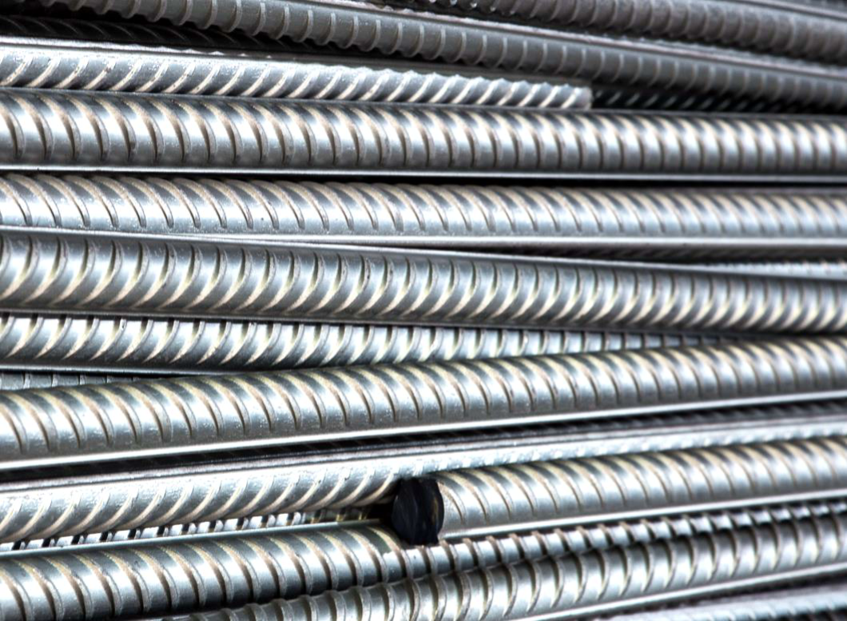
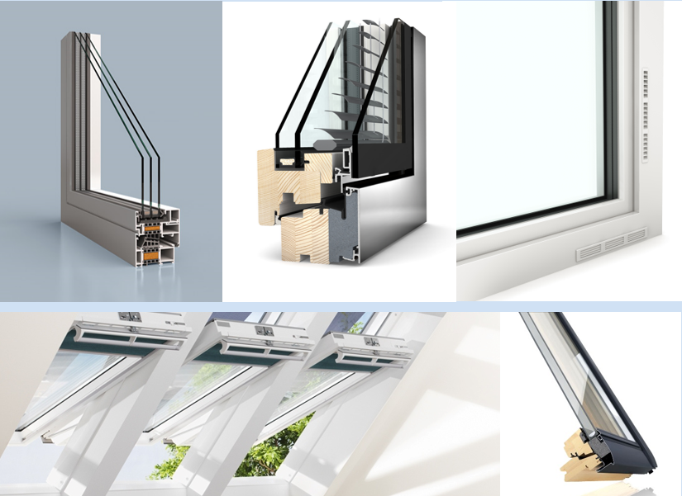
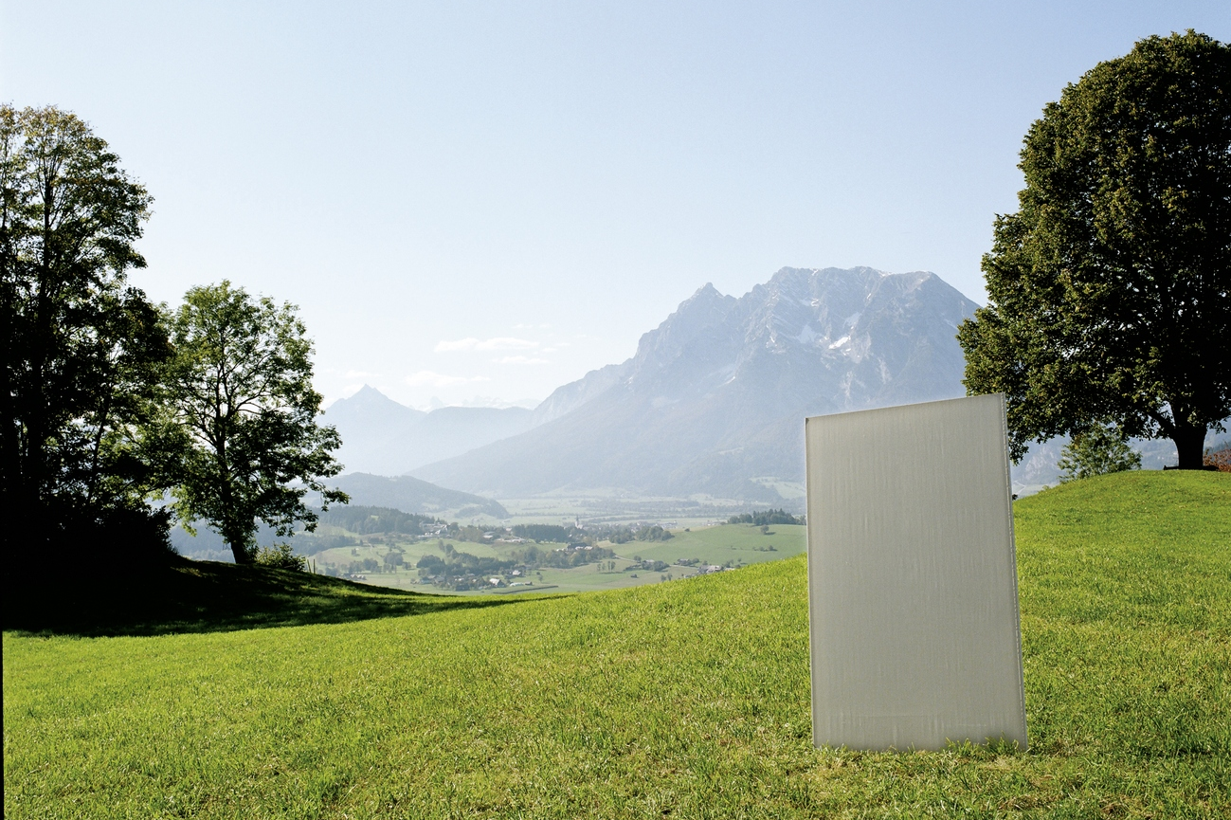

Imprint

Publisher:

Bau EPD GmbH

Seidengasse 13/3
A-1070 Vienna
Austria
http://www.bau-epd.at
office@bau-epd.at

© Bau EPD GmbH

Picture credits frontpage:
AFI Aluminiumfensterinstitut, www.alufenster.at, Fa. Velux, www.velux.at, Fa. Internorm, www.internorm.com

Tracking of versions

Version | Comments | Date of changes
6.0 | New structure following decisions of TAC from 2017-05-11, adaptations following resolutions from TAC in autumn 2016 and 2017. | 2017-08-17
7.0 | Changes following decisions of TAC since last publication. Changes on occasion of verification of PCR for concrete and concrete elements as well as resulting from working out the PCR for steel reinforcement. Changes to be made in all PCR B parts as well as some editorial chances. Index now included. | 2019-07-06
8.0 | Adaptation as per EN 15804:2019+A2:2019; adaptation of rules for declaration of geographical representativity | 2020-11-05
9.0 | Public version for interested parties after approval of PCR review panel. | 2021-01-12
10.0 | Consideration of comments, approval for EPD creation | 2021-04-07
11.0 | Adaptation tables module B and C, minor editorial changes | 2021-08-27
13.0 | Revision through extended PGF, change in tables with technical characteristics, foreword, change in ECO Platform logo, note on photo rights, created by PGF and SR, (checked by FG and released for EPD creation by SR) | 2022-03-23
14.0 | Addition of accreditation mark, change owner, publisher, holder of declaration, specification of CF factors, editorial changes, title page EPD declaration of Energy Mix Approach,  (created by SR, checked by FG and approved by SR) | 2023-01-27

Contents

1. Scope 5
Requirements on the layout of the EPD 6
Content of the EPD 6
1. General information 8
2. Product 10
2.1 General product description 10
2.2 Application field 10
2.3 Standards, guidelines and regulations relevant for the product 10
2.4 Technical data 11
2.5 Basic/auxiliary materials 12
2.6 Production 14
2.7 Packaging 14
2.8 Conditions of delivery 14
2.9 Transport 14
2.10 Processing/ installation 14
2.11 Use stage 15
2.12 Reference service life (RSL) 15
2.13 Reuse and recycling 15
2.14 Disposal 15
2.15 Further information 15
3. LCA: Calculation rules 17
3.1 Declared unit/ Functional unit 17
3.2 System boundary 18
3.3 Flow chart of processes/stages in the life cycle 20
3.4 Estimations and assumptions 20
3.5 Cut-off criteria 20
3.6 Data sources 20
3.7 Data quality 20
3.8 Reporting period 20
3.9 Allocation 20
3.10 Comparability 21
4. LCA: Szenarios and additional technical information 21
4.1 A1-A3 product stage 21
4.2 A4-A5 Construction process stage 21
4.3 B1-B7 use stage 22
4.4 C1-C4 End-of-Life stage 23
4.5 D Potential of reuse and recycling 24
5. LCA: results 25
6. LCA: Interpretation 28
7. Literature 29
8. Directory and Glossary 29
8.1 List of figures 29
8.2 List of tables 29
8.3 Abbreviations 30

Foreword
Product category rules (PCR) are a set of specific rules, requirements or guidelines to create Type III environmental declarations standard according to EN ISO 14025 for one or more product categories. This adds to overarching regulations for life cycle assessment (e.g. the ISO 14040 series of standards). While ISO standards must be applicable to all products that exist and therefore (must) be kept general, rules are needed for construction products that ensure product-specific comparability. Otherwise, there would be too much room for interpretation and options in the course of calculating EPD data of construction materials.
With EN 15804, there has been a standard since 2012 that regulates many things for construction products, it can be regarded as the core PCR. Nevertheless, many details of LCA modelling are still open. For this reason, there is an effort in national and international standardization institutes as well as in almost all EPD programmes to establish conventions for individual construction product categories and to coordinate them as best as possible. In doing so, process-technical realities in the manufacture of construction products, use and circumstances at the end of the life cycle of buildings and products should be taken into account, as well as prevailing legal regulations such as e.g. waste management regulations. When it comes to benchmarking at product or building level, the input values ​​must be as comparable as possible.
With ÖNORM EN 17213, edition: 2020-08-15, a European PCR for windows and doors has already been adopted.
The complementary PCR rules on hand, created by Bau EPD GmbH together with science and industry, serve to sensibly coordinate the PCR rules for Austria that are already on the market. At first glance, these "additional rules" appear to be a hurdle, but at second glance they ensure fairness, transparency and legal compliance.

Scope
This document contains the Requirements on an Environmental Product Declaration (EPD) as per EN 15804 and ISO 14025 and requirements of Bau EPD GmbH.

The document applies to:
• Windows (vertical windows including fixed glazing and skylights according to ÖNORM EN 14351-1 and fire and smoke protection windows according to ÖNORM EN 16034 and façade systems with glazing according to ÖNORM EN 13830 / 2003, furthermore ÖNORM B5300 is window - requirements - supplements to ÖNORM EN 14351-1 to comply with
• Skylight domes according to ÖNORM EN 1873 (prefabricated accessories for roof coverings - skylight domes - product specifications and test methods)
• Rooflight strips ÖNORM EN 14963 (roof coverings - rooflight strips with or without curbs; classification, requirements and test methods).
• Flat roof windows (horizontal windows) and inclined glazing
• Doors (external and internal doors) according to ÖNORM EN 14351-1 and pr EN 14351-2 + fire protection doors according to ÖNORM EN 16034, ÖNORM B 3850 and ÖNORM B 3851, furthermore ÖNORM B5339 external doors - requirements - supplements to ÖNORM EN 14351-1

including the system components: profiles, coatings, fillings (transparent and opaque, the type of filling is to be specified in the EPD), seals, integrated ventilation components and drives.

Locks and fittings are to be accounted for, building connections are not included.

Also not included are:
- Closures that are not part of the window (definition according to ÖNORM EN 14351-1).
- Automatic and revolving doors

The requirements on the EPD include:
- Requirements from EN ISO 14025
- Requirements on the EN 15804 standard as a European core EPD
- EN 17213:2020 - Windows and doors - Environmental product declarations - Product category rules for windows and doors
- Complementary requirements on EPD of Bau EPD GmbH

The calculation rules for the Life Cycle Assessment and Requirements on the project report are specified in a separate document – “Management System Handbook chapter 5” of Bau EPD GmbH.

Requirements on the layout of the EPD
Bau-EPD GmbH determines the following features with regard to the layout of the EPD:

- The document on hand defines the format template for EPD-document that is to fill in (Word file „Format template EPD Bau EPD GmbH“, download at www.bau-epd.at).
- The content of an EPD is not limited in length of text.
- The layout of the front page of the EPD is defined and picture material must be accorded with Bau EPD GmbH (not more than 4 MB).
- On the last page of the EPD the publishing institution as well as the programme operator (Bau EPD GmbH in both cases), the LCA practitioner and owner of the declaration must be indicated with a logo and full address (including telephone number, fax number, email and website).
- Generally the font „Calibri“ must be used.
- In addition to the EPD as Microsoft Word format an Excel-document (BAU EPD M-DOCUMENT 8- excel-file for electronic data transfer Editor baubook ECO Platform) must be created including the result tables for electronic transfer and complying to EN 15942 (ITM Matrix). The templates of Bau EPD GmbH must be used, for these tables also serve to forward data to database owners (ECO Platform/ECO Portal, OEKOBAUDAT and BAUBOOK).

Content of the EPD
The following format template respective guidance describes the required structure of the EPD document including the required content for each individual chapter.
In addition to that, this document is giving specific notes for the creation of an EPD for windows, doors and façade systems and specific LCA calculation rules for windows, doors and façade systems that must be considered when creating the EPD and underlying LCA study.

Parts of the content that are considered as additional information of optional character (=not required as per international standard and/or guidelines from ECO Platform) are marked in lilac colour. This information is free to choose whether to declare or not and indications can be delivered by the owner of the declaration on optional basis.

Legend:
Blue: required content for each chapter
Turquoise: specific requirements for EPD of materials from the scope of the PCR
Green: specific LCA rules for EPD of material from the scope of the PCR
Violet: additional information of optional character

EPD - ENVIRONMENTAL PRODUCT DECLARATION

As per ISO 14025 and EN 15804
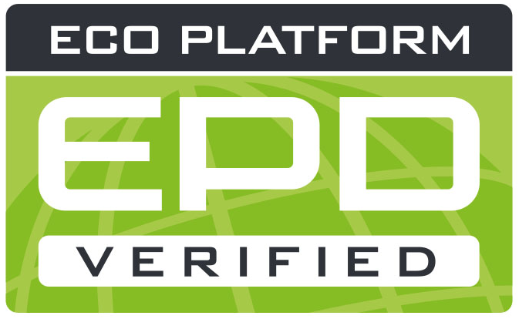
OWNER AND Publisher Bau EPD GmbH, A-1070 Wien, Seidengasse 13/3, www.bau-epd.at
Programme Operator Bau EPD GmbH, A-1070 Wien, Seidengasse 13/3, www.bau-epd.at
HOLDER of the Declaration Name of declaration holder
Declaration Number To be accorded with Bau EPD GmbH
Issue Date Date
Valid To Date
NUMBER OF DATASETS Number
ENERGY MIX APPROACH MARKET BASED APPROACH

Name and description of product
Name of declaration owner

picture
To be accorded with declaration owner and Bau EPD GmbH
(Note: photographic rights must be clarified and cited)

Company logo of declaration owner

Contents:

Content of the EPD 6
1. General information 8
2. Product 10
2.1 General product description 10
2.2 Application field 10
2.3 Standards, guidelines and regulations relevant for the product 10
2.4 Technical data 11
2.5 Basic/auxiliary materials 12
2.6 Production 14
2.7 Packaging 14
2.8 Conditions of delivery 14
2.9 Transport 14
2.10 Processing/ installation 14
2.11 Use stage 15
2.12 Reference service life (RSL) 15
2.13 Reuse and recycling 15
2.14 Disposal 15
2.15 Further information 15
3. LCA: Calculation rules 17
3.1 Declared unit/ Functional unit 17
3.2 System boundary 18
3.3 Flow chart of processes/stages in the life cycle 20
3.4 Estimations and assumptions 20
3.5 Cut-off criteria 20
3.6 Data sources 20
3.7 Data quality 20
3.8 Reporting period 20
3.9 Allocation 20
3.10 Comparability 21
4. LCA: Szenarios and additional technical information 21
4.1 A1-A3 product stage 21
4.2 A4-A5 Construction process stage 21
4.3 B1-B7 use stage 22
4.4 C1-C4 End-of-Life stage 23
4.5 D Potential of reuse and recycling 24
5. LCA: results 25
6. LCA: Interpretation 28
7. Literature 29
8. Directory and Glossary 29
8.1 List of figures 29
8.2 List of tables 29
8.3 Abbreviations 30

General information

Product name  Name and description of product | Declared Product / Declared Unit  Description of the declared product and declared unit/functional unit  Number of datasets in EPD Document(s): XX  Range of validity  The products considered in the data of the life cycle assessment and for which the declaration applies must be named.  In the case of an average EPD, this type of EPD must be pointed out.  The representativeness of the declaration must be shown with regard to the production volume covered by the life cycle assessment and the technology used. Likewise, the range of fluctuation of the product group considered, must be specified in the interpretation.
Declaration number
To be accorded with Bau EPD GmbH
Declaration data
Specific data
Average data

Declaration based on:
MS-HB version dated dd.mm.yyyy:
Name of PCR
PCR Code
Version
(PCR tested and approved by the independent expert committee
= PKR-Gremium)
The owner of the declaration is liable for the underlying information and evidence; Bau EPD GmbH is not liable with respect to manufacturer
information, life cycle assessment data and evidence.
Type of Declaration as per EN 15804  From cradle to ... .....  LCA-method: (i.e. Cut-off by classification) | Database, Software, Version  Declaration of backround database, Software used and both its versions  Version Characterisation Factors: Quelle, Version
Author of the Life Cycle Assessment  Name of the author  Institution, Address  website | The CEN standard EN 15804:2014+A1 serves as the core-PCR.  Independent verification of the declaration according to ISO 14025:2010  internally externally  Verifier 1: Name  Verifier 2: Name
Holder of the Declaration  Name of the manufacturer/owner  Institution, Address  website | Owner, Publisher and Programme Operator  Bau EPD GmbH  Seidengasse 13/3  1070 Vienna  Austria

DI (FH) DI DI Sarah Richter
Head of Conformity Assessment Body

Academic Title Name Academic Title Name,
Verifier Verifier

Note: EPDs from similar product groups from different programmes might not be comparable.

Product

General product description

For the product description the characteristics of the declared product must be described. In case of average EPD (“sector or branch” EPD) all declared products must be described separately.

Indications for the general product description:
- Separate description of products/materials for each product standard applicable, citing the product types and names.
- Description of characteristic components.
- All factory locations for the respective product categories must be declared, alternatively a reference can be made to an overview in an appendix (mandatory information in the project report, voluntary information in the EPD document)

Specific notes for the creation of an EPD for windows, doors and façade systems:

The declared products must be described in detail and presented graphically (e.g. CAD drawing, a view and a principle section). If averages are declared for different products, the formation of the average must be explained in a comprehensible manner. This must always be weighted according to production volume.

Exemplary information:
• Window frame / sash frame (type of building material)
• Surface (treatment/coating)
• Window ventilator (to be specified if necessary)
• Fillings / glasses
• Non-transparent fillings (material and structure to be specified)
• Gaskets (material to be specified).
• Fittings (specifications of straps, clasps and functional fittings)

In addition, a reference to the system description (e.g. link to the company or product website) must be given.

Application field

The use and application purpose of the named products are to specify. The individual applications (including functions) must be declared as a text or table format.
Specific notes for the creation of an EPD for windows, doors and façade systems:
Use in residential and non-residential buildings, indoors, outdoors, fire protection, additional information, etc.

Standards, guidelines and regulations relevant for the product

The respective standard and/or general technical approval or comparable national regulation can be indicated.

Optional: Documentation under the frame of CE -certification such as certificates of constancy of performance, certificates of conformity of the internal production control on the manufacturer’s site, Declarations of performance, Official certificates of registration, European Technical Assessments or Technical permissions of construction industry can be cited.

Specific notes for the creation of an EPD for windows, doors and façade systems:
The standards regulating windows, doors and façade systems must be cited (i.e. standards, guidelines, other regulations)
Examples for product standards for windows, doors and façade systems in Austria are illustrated in table 1.

Table 1: Product specific standards
Standard | Title
ÖNORM EN 14351-1: 2016-11-01 | Windows and doors - Product standard, performance characteristics - Part 1: Windows and external doors without fire resistance and/or smoke resistance characteristics
ÖNORM B 5300 | Windows - Requirements - Supplements to ÖNORM EN 14351-1
ÖNORM EN 16034:2015 01 01 | Doors, gates and windows - Product standard, performance properties - Fire and/or smoke control properties
ÖNORM B 5339 | External doors - Requirements - Supplements to ÖNORM EN 14351-1
ÖNORM EN 13830: 2003 11 01 | Curtain walls, German version EN 13830:2003
ÖNORM B 3850: 2014-04-01 | Fire protection barriers - revolving doors and gates as well as swing doors - requirements and tests for single and double-leaf elements
ÖNORM B 3851: 2014-07-15 | Smoke protection barriers - revolving and swinging doors and gates - requirements and tests for single and double-leaf elements

Technical data

For products carrying a CE marking as per Construction Products Regulation (CPR) the EPD must declare at least the same technical data as required and indicated in the declaration of performance of the manufacturer. What kind of data is required in each individual case is to learn from the document underlying the CE marking: any Harmonized European Standard or European Technical Assessment (ETA).
Additional technical data must be listed if relevant for product distinction or specification.

Specific notes for the creation of an EPD for windows, doors and façade systems:
The (construction) technical data listed in Table 2 and Table 3 are based on the national standards or the harmonized European product standards for windows, doors and glass façade elements and must be specified with reference to the test standard. The data correspond to the information required for the declaration of performance in OIB-095.2-015/19.

Table 2: Technical data of the declared building product according to ÖNORM EN 14351-1 (windows, balcony doors, doors and skylights)
Characterization | Value | Unit
Windows:
Driving rain tightness according to ÖNORM EN 12208 |  | Class
Resistance to wind loads according to ÖNORM EN 12210 |  | Class
Mechanical stress according to ÖNORM EN 12400 |  | Class
Impact resistance according to ÖNORM EN 13049 |  | Class
Sound insulation according to ÖNORM EN ISO 717-1 |  | dB
Heat transfer coefficient glass (Ug) according to ÖNORM EN 673 |  | W/(m²K)
Thermal transmittance window ( Uw ) according to ÖNORM EN ISO 10077-1 |  | W/(m2K)
Total energy transmittance according to ÖNORM EN 410 |  | %
Light transmittance according to ÖNORM EN 410 |  | %
Air permeability according to ÖNORM EN 12207 |  | Class
Burglar resistance according to ÖNORM B 5338 |  | Class
Fire protection window:
Classification according to ÖNORM EN 13501-2 |  | Class
External doors:
Driving rain tightness according to ÖNORM EN 12208 |  | Class
Resistance to wind loads according to ÖNORM EN 12210 |  | Class
Mechanical stress according to ÖNORM EN 12400 |  | Class
Impact resistance according to ÖNORM EN 13049 |  | Class
Sound insulation according to ÖNORM EN ISO 717-1 |  | dB
Heat transfer coefficient glass (Ug) according to ÖNORM EN 673 |  | W/(m²K)
Heat transfer coefficient door ( Ud ) according to ÖNORM EN ISO 10077-1 |  | W/(m²K)
Total energy transmittance according to ÖNORM EN 410 |  | %
Light transmittance according to ÖNORM EN 410 |  | %
Air permeability according to ÖNORM EN 12207 |  | Class
Burglar resistance according to ÖNORM B 5338 |  | Class
Climatic load according to ÖNORM EN 1121 and ÖNORM EN 12219 |  | Class
Ability to release (only locked doors in escape routes) |  | -
Fire and smoke protection doors:
Classification according to ÖNORM EN 13501-2 |  | Class
roof window:
Driving rain tightness according to ÖNORM EN 12208 |  | Class
Resistance to wind loads according to ÖNORM EN 12210 |  | Class
Mechanical stress according to ÖNORM EN 12400 |  | Class
Impact resistance according to ÖNORM EN 13049 |  | Class
Resistance to snow and permanent loads (EN 12833 roller shutters for roof windows and conservatories "Resistance to snow loads" or Eurocode 1 or ÖNORMEN B 1991-1 and -3)
Sound insulation according to ÖNORM EN ISO 717-1 |  | dB
Heat transfer coefficient glass (Ug) according to ÖNORM EN 673 |  | W/(m2K)
Length-related heat transfer coefficient ( Ψg ) according to ÖNORM EN ISO 10077-2 |  | W/mK
Heat transfer coefficient frame (Uf) according to ÖNORM EN ISO 10077-2 |  | W/(m2K)
Thermal transmittance window ( Uw ) according to ÖNORM EN ISO 10077-1 |  | W/(m2K)
Total energy transmittance according to ÖNORM EN 410 |  | %
Light transmittance according to ÖNORM EN 410 |  | %
Air permeability according to ÖNORM EN 12207 |  | Class

Table 3: Technical data of the declared construction product according to ÖNORM EN 13830 (curtain façades)
Characterization | Value | Unit
tightness against driving rain |  | Class  (Pa)
Resistance to wind load |  | Class  (Pa)
Impact resistance/resistance to breakage |  | Class  (mm)
Direct airborne sound insulation Rw (C;Cu) |  | dB
Heat transfer coefficient glass ( Ucw ) |  | W/(m2K)
air permeability |  | Class
burglar resistance |  | Class

For specific EPD the technical data of the product must be declared as required in Table 2 to Table 4.
For average EPD (“Sector or Branch-EPD“, “Group EPD” or “EPD from Associations”) Table 2 must be filled, average values or ranges are accepted, in addition a note stating „see product sheets“ pointing to single technical product sheets can be cited. Technical data must be provided by the manufacturers. The manufacturers are to ensure that the relevant data are accessible, and the LCA-practitioner must indicate the sources where the technical data can be downloaded.
In this case the average value of nominal density/ weight per m² used for calculating the LCA must be declared as an additional information in chapter 3.1.

Basic/auxiliary materials

The product components and/or contents and ingredients must be declared in mass-% to enable the user of the EPD to understand the composition and structure of the product in delivery status. These indications shall also support security and efficiency in installation, use and disposal of the product.

The declaration of mass-% can be accurate numbers or a range by analogy with REACH . The mass of components that make up less than 1 mass-% of the total product mass can be declared with < 1 mass-%.

The declaration of material product content must list at least those substances contained in the product which are included in the “Candidate List of Substances of Very High Concern for Authorization” where their contents exceed the limit values (0.1 mass-% on product level) for registration by the European Chemicals Agency (ECHA). If substances and preparations lose their hazardous features during manufacturing (e.g. after a complete chemical reaction) they are exempted from the obligation of declaration.
If the content of the material is below the limit of ECHA the following note must be stated in the EPD:
„The content of XXXX is below the limit values of the registration by the European Chemicals Agency (ECHA). Interpreting statements such as “… free of …” or “… are entirely harmless …” are not permissible.

The product components must be described in detail, so that their sort of product is clear, but the protection of sensitive data is assured, and company secrets are not revealed.
For additives, the function and substance class respective chemical group (i.e. hydraulic binders) must be stated. In addition to that all auxiliary materials and additives that stay within the product must be declared.

Specific notes for the creation of an EPD for windows, doors and façade systems:
Constituents (Element Type) | characterization (material) | function (description) | Mass % | Weight kg
 | designation x)
main profiles | e.g. aluminium, wood, plastic, composite material | e.g. inner shell or post
 | e.g. aluminium, wood, plastic, composite material | e.g. outer shell or latch
surface coating | e.g. anodizing, powder coating, coating, wood protection
accesories | e.g. INOX | e.g. glass holder
 | e.g. cellular rubber | e.g. butt seal 130mm
Accessory Profiles | e.g. aluminium, wood, plastic, composite material | e.g. glazing bead
 | e.g. aluminium, wood, plastic, composite material | e.g. pressure profile
 | e.g. aluminium, wood, plastic, composite material | e.g. spacers
seals | e.g. EPDM | e.g. circumferential stop seal
 | e.g. butyl rubber | e.g. butyl tape 45 mm
glazing | e.g. float glass | free designation,
 | e.g. coating | e.g. ISO 6-14-4-14-4
spacer glazing | e.g. product name | function (description)
fillings | e.g. argon
Opaque panels | (Layer structures, e.g. metal sheets and insulating layers) | e.g. inner shell or post
total | characterization (material) | e.g. outer shell or latch | 100 | Sum

Note: The formulation of PVC should be broken down in mass percentage (an extra table can be made for this)

^{x)} Optional: footnote with description for each component

x) Text
x) Text
x) Text
Auxiliaries / additives
Specifications and proportions of excipients are to be stated (in text or tabular format)

Production

The process of production must be described and illustrated with a simple figure (i.e. flow chart). In case of average EPD the production processes of all sites must be described respective a useful summary must be included and a list of all production sites must be provided in an annex. Quality management systems, eco management systems etc. can be referred to.

Specific notes for the creation of an EPD for windows, doors and façade systems:
Herkunft und Anteil der Rohstoffe, herstellerspezifische und spezielle Prozessketten, besondere Verarbeitungsmethoden.

Figure 1: Example of a flow chart/graphic production stage

Description of chart

Packaging

Information concerning each component of packages:

Type (Foil, pallets, etc.),
Material (Paper, Polyethylene; including origin, e.g. recycled paper) and
Possibilities of reuse (e.g. multi way pallets).

Specific notes for the creation of an EPD for windows, doors and façade systems:
The description can be multi-level (from the system manufacturer to the processor and the usual type of packaging from the processor to the construction site).

Conditions of delivery

Written description of conditions of delivery, units of delivery, size and dimension as well as requirements on storage important for the declared product(s).
Specific notes for the creation of an EPD for windows, doors and façade systems:
The description can be multi-level (e.g.: in the 1st part, the system manufacturer delivers to the processing company. The processing company then delivers the finished element to the construction site in the 2nd part).

Transport

Description of delivery (Route and means of transport).

Processing/ installation

Description of way of treatment, used machines, tools, dust collection etc., auxiliary materials as well as measures of noise reduction. Notes regarding recognized rules of engineering, work safety or protection of the environment can be included.
References to detailed processing directives and referrals to user safety (safe use instruction sheets) of the manufacturer are required.

Use stage

Notes describing specific features of the material composition relevant for the use stage.

Specific notes for the creation of an EPD for windows, doors and façade systems:
In the case of windows, doors and façade systems, there are no changes in the material composition over the period of use if they are properly planned, properly and professionally installed and used without problems.

Reference service life (RSL)

The indication of the reference service life (RSL) is imperative for EPDs covering the complete use stage (modules B1-B7), or if a use stage scenario is described, which refers to the lifetime of the product (“from cradle to grave”).
The RSL must refer to the declared technical and functional quality of the product. It must be established in line with all of the specific rules in the European product standards and must also take consideration of the ISO 15686-1, -2, -7 and -8 standards.
Where information is available for deriving the RSL from harmonized European product standards, such data has priority.
The assumption underlying the calculation of the RSL and for those only the RSL can be declared must be stated. Influence on aging as per recognized rules of engineering.

Table 4: Reference service life (RSL)
Characterization | value | unit
Windows |  | years
Doors |  | years
Façade systems |  | years
Reference conditions on which the RSL is based (if relevant) |  | Individual units

See EN 15804+A2 clause 6.3.4 and Annex A requirements and guidelines for reference service life

If no reference service life can be determined according to the rules of EN 15804+A2 (Annex A), a default value from a complementary PCR of the CEN/TC product committees, if available, must be used. If no complementary PKR is available, the service life can be declared from service life catalogues, depending on the area of ​​application, stating the source, e.g. according to BAU EPD-M-DOKUMENT-20-Reference-usage-times-20150810 (Austria) or the BBSR table "Useful lives of components on life cycle analysis according to BNB” (Germany). If no information can be found there, the RSL can be derived from other sets of regulations (Eurocodes, other basis).

Reuse and recycling

Possibilities and scenarios of reuse and recycling must be described.

Disposal

The different ways of disposal must be described.
The EAK-waste disposal code (Disposal code following the European list of waste) must be declared.

Further information

Optional details, indication of reference source for additional information, e.g. websites…

LCA: Calculation rules

Declared unit/ Functional unit

The declared resp. functional unit, the mass reference and the conversion factor to 1 kg must be declared in a table.

Specifications for the functional or declared unit are to be adopted in accordance with EN 17213:
The declared unit for all product types must be 1 m2. The declaration of the results per window/other dimension is also possible. Conversion factors can also be specified. The indicator results should be calculated for elements with standard dimensions (as listed below) and then declared per square meter of the product in the EPD. The configuration and dimensions used for the calculation shall be clearly stated in the EPD and the standard dimensions given below should be used for the calculation:
Standard dimensions stick outside:
- Window 1.23m x 1.48m (≤ 2.3m²)
- French door 1.48 m x 2.18 m (> 2.3 m2)
- Doors (house and entrance doors) 1.23 m x 2.18 m (≤ 3.6 m2)
2.00m x 2.18m (> 3.6m2)
- Door height for sliding/folding elements 3.00 m X 2.18 m
Does the manufacturer want to provide LCA indicator results for an element with non-standard dimensions. the manufacturer may either:
(a) provide, as additional information, the indicator results for the following optional measures:
Optional dimensions:
Window 1.48m x 2.18m
Doors 1.48m X 2.18m
Door height for sliding/folding elements 6.00 m x 2.18 m
or (b) provide indicator results for item dimensions other than those listed above to reflect actual items manufactured. In such a case, the exact dimensions used and a sketch of the element must be included in the EPD. This size-specific EPD is not to be used as a proxy for other sizes of the item.
Functional unit:
The functional unit must be defined in accordance with the declared unit and the reference service life. It is considered good practice to indicate the technical characteristics of the product relevant to the use phase in order to facilitate the calculation of the works. For windows and doors that would be e.g. B. Heat transfer coefficient and radiation properties. If such characteristics are given, they must be established in accordance with the relevant harmonized product standards.
The declared characteristics for windows and doors, developed in accordance with the relevant harmonized product standards, are important but must be viewed in the context of the building. Such parameters are strongly influenced by factors such as the dimensions and orientation of the product, as well as the local climate. These factors are not always present in product standard data taken into account. For example, a declaration of performance can be based on a "standard" dimension and deviate from the performance in the dimensions actually installed.
For guidelines on the definition of representative products within a product line, see ÖNORM EN 17213 - Appendix A.
If averages are declared for different products, the formation of the average must be explained.
In this case, the average value used in the life cycle assessment and the range for the raw density must be stated.
Note: in order to ensure the comparability of window and facade products, the following specifications must be applied when calculating the average:
Averaging at product level is possible if the application and product properties and frame material are basically identical:
In any case, the type of glazing (double, triple glazing and the associated frame portion) must be differentiated.
Example: in an industry EPD, for example, an average of various wood-aluminium windows (from different manufacturers, factories) with double glazing can be given in one column, and the average with triple glazing in a second column.

System boundary

The type of EPD with regard to the applied system boundaries must be specified in the EPD. All building products and materials must declare modules A1-A3, modules C1-C4 and module D. The following EPD types may be specified:
• from the cradle to the factory gate with modules C1-C4 and module D (A1-A3 + C + D);
• from the cradle to the factory gate with options, modules A1-A3, C1-C4 and D (A1-A3 + C + D and additional modules. The additional modules may be one or more modules selected from A4 to B7);
• from cradle to grave and module D (A + B + C + D)
Exceptions to this rule are specified in EN 15804+A2, chapter 5.2.
Note: The specifications for the modules that must be declared no longer correspond to ÖNORM EN 16783:2017 - the specifications from EN 15804:2019+A2 apply primarily.
All declared life cycle stages (modules) are to be marked with an "X" in Table 7. Undeclared modules are to be marked with ND (= not declared).

Table 5: Declared life cycle stages
PRODUCT STAGE |  |  | CON-STRUCTION PROCESS STAGE |  | USE STAGE |  |  |  |  |  |  | END-OF-LIFE STAGE |  |  |  | BENEFITS  AND LOADS BEYOND THE SYSTEM BOUNDARIES
A1 | A2 | A3 | A4 | A5 | B1 | B2 | B3 | B4 | B5 | B6 | B7 | C1 | C2 | C3 | C4 | D
Raw material supply | Transport | Manufacturing | Transport from the gate  to the site | Construction, installation | Use | Maintenance | Repair | Replacement | Refurbishment | Operational energy use | Operational water use | De-construction, demolition | Transport | Waste processing | Disposal | Reuse-  Recovery-  Recycling-  potential
x | x | x | x | x | x | x | x | x | x | x | x | x | x | x | x | x
X = included in LCA; MND = Module not declared
The modules assessed in the LCA study must be described shortly. It should be made apparent, which processes are calculated in which module and how the system boundaries to nature resp. to other product systems are set (if relevant for the declared product).

If not all modules are declared in an EPD, a clear justification must be given.

Specific LCA calculation rules for windows, doors and façade systems:
A1-A3
• The life cycle assessment of wooden window scantlings must be carried out in accordance with PKR Part B: Requirements for the EPD for solid wood products.
• The life cycle assessment for metal profiles must be carried out in accordance with PKR Part B: Requirements for the EPD for construction metals.
• Use of generic data for EPDs
The general rules for life cycle assessments (MS-HB) state that if a preliminary product accounts for more than 10% of the calculated impact categories, specific data for the preliminary product should be collected. In the case of the window EPD, the use of generic data for balancing the raw materials (metals, PVC granules, wood, glass, etc.) is permitted if specific data cannot be collected. The reasons must be documented in the project report. Generic data can be used with appropriate representativeness or based on a conservative scenario. The generic data sets used must be complete.
o If no specific data can be submitted by the window manufacturer for the production of the primary product, the most suitable data set of primary material from the current ecoinvent database will be used. If plausible evidence is provided for the proportion of secondary material used, this is approximated using the most suitable data set for secondary raw materials. A suitable data set for the shaping of profiles must also be considered.
o In the event of data uncertainty, the most conservative approach is always chosen.
The procedure for data from GaBi applies analogously.
The minimum requirement for creating a product-specific EPD is complete inventory data for window or door production.

A4-A5
If material losses occur with window or facade products, although the products are usually delivered to the construction site, this must be documented (e.g. sealing tapes, foam products, etc.).
B1-B7
ÖNORM B 5305 - Windows - Control and maintenance is to be observed when creating scenarios
C1 - C4 and D
In the disposal phase, proceed as follows:
Recycling scenarios are to be balanced for the metal parts. A disposal scenario is to be balanced for the glass portion. In any case, a disposal scenario must be considered for wood and plastic components. Recycling scenarios should also be specified.
The declaration of Module D is expressly recommended.

Flow chart of processes/stages in the life cycle

A meaningful flow chart describing the manufacturing process shall give further aid to comprehension. The flow chart must be subdivided at least into the phases of life cycle declared (production, use, end-of-life). The phases can be partitioned into appropriate process stages.

Estimations and assumptions

The assumptions and assessments that are important for the interpretation of the life cycle assessment are to be listed here.

Cut-off criteria

The application of the cut-off criteria according to MS-HB Chapter 5.5.3 must be documented here.

Data sources

The quality of the collected data must be described.

Data quality

The sources of the backround data sets must be declared. If necessary, additional information on the quality of the used data sets shall be made (estimations). The issuing year of the used data material must be indicated.

Reporting period

The period under review must be documented (in case of average EPD this would be the basis of the calculated average).

Allocation

The allocations of relevance for calculation (appropriation of expenses across various products) must be indicated, at least:
- System boundary settings/allocation in the use of recycled and/or secondary raw materials
- Allocation concerning co-products
- Allocation of energy, auxiliary and operating materials used for individual products in a factory
- Loads and credits from recycling or energy recovery of packaging materials and production waste
- Loads and credits from recycling or energy recovery from the end of life of the product

whereby reference must be made to the modules in which the allocations are performed.
Detailed regulations concerning calculation of secondary materials and allocation MS-HB chapter “LCA rules” apply in all studies.

Comparability

With reference to comparability of EPD data the following facts must be mentioned:

Comparison or benchmarking of EPD data is only possible, if all compared data sets are calculating following EN 15804 in the same version, the same programme specific PCR-rules or other additional rules. The same backround data sources and software versions must be applied. Moreover, the context of the function in the building or product specific features of performance must be considered.

LCA: Scenarios and additional technical information

The following information is mandatory to give for all declared modules, for modules not declared it is optional. If need, additional information can be declared.

A1-A3 product stage

Following EN 15804 no scenario documentation is required for A1-A3 for the declaration and calculation of these modules lies within the responsibility of the manufacturer and must not be altered by the LCA practitioner.
Note: the masses of packaging per declared unit must be indicated, this is especially important if A5 is not declared.

A4-A5 Construction process stage

Table 9 and the units listed must be used for calculation the environmental impact of the transport phase.
Table 10 and the units listed must be used for calculation the environmental impact of the installation into the building.

Table 6: Description of the scenario „Transport to building site (A4)“
Parameters to describe the transport to the building site (A4) | Quantity per unit
Average transport distance | km
vehicle type, Commission Directive 2007/37/EC (European Emission Standard) | -
Fuel type and average consumption of vehicle | l/100 km
Maximum transport mass | tons
Capacity utilisation (including empty returns) | %
Bulk density of transported products | kg/m³
Volume capacity utilisation factor (factor: =1 or <1 or ≥ 1 for compressed or nested packaged products) | -
^{x)} The table must be filled with reference to the information available from the datasets used (i.e. in case of transport by ship). The datasets used must be noted in a footnote.

Table 7: Description of the scenario „Installation of the product in the building (A5)“ as per table 8 in ÖNORM EN 15804
Parameters to describe the installation of the product in the building (A5) | Quantity per unit
Ancillary materials for installation (specified by material); | Meaningful unit
Water use | m³
Other resource use | kg
Electricity demand | kWh or MJ
Other energy carrier(s): ……………. | kWh or other unit (e.g. litres)
Wastage of materials on the building site before waste processing, generated by the product’s installation (specified by type) | kg
Output materials (specified by type) as result of waste processing at the building site e.g. of collection for recycling, for energy recovery, disposal (specified by route) | kg
Direct emissions to ambient air, soil and water | kg

B1-B7 use stage

Reference Service life: [a]
The parameters and the units listed in the following tables must be used for calculation the environmental impact of the use stage (B2-B7). The tables can be excluded if no input or output happens. In this case a note of explanation would be sufficient: “In module BX-BY no material resp. mass flows occur, input +/- output = 0

Table 8: Description of the scenario „maintenance (B2)“ based on table 9 in EN 15804
Parameters maintenance (B2) | value | unit
Maintenance process |  | Description or source where description can be  found
Maintenance cycle |  | Number per RSL or year ª
Ancillary materials for maintenance, e.g.  cleaning agent, specify materials |  | Kg/cycle
Waste material resulting from maintenance (specify materials) |  | kg
Net fresh water consumption during maintenance |  | m³
Energy input during maintenance, e.g. vacuum cleaning, energy carrier type, e.g. electricity, and amount, if applicable and relevant |  | kWh

Table 9: Description of the scenario „repair (B3)“
Parameters repair (B3) | value | unit
Repair process |  | Description or source where description can be  found
Inspection process |  | Description or source where description can be  found
Repair cycle |  | Number per RSL or year
Ancillary materials, e.g. lubricant, specify  materials |  | Kg or kg/cycle
Waste material resulting from repair, (specify materials) |  | kg
Net fresh water consumption during repair |  | m³
Energy input during repair, e.g. crane activity,  energy carrier type, e.g. electricity, and amount |  | kWh

Table 10: Description of scenario „replacement (B4)“
Parameters replacement (B4) | value | unit
Replacement cycle |  | Number per RSL or year
Energy input during replacement e.g. crane  activity, energy carrier type, e.g. electricity and  amount if applicable and relevant |  | kWh
Exchange of worn parts during the product’s life cycle, e.g. zinc galvanised steel sheet, specify materials |  | kg

Table 11: Description of scenario „refurbishment (B5)“

Parameters refurbishment (B5) | value | unit
Refurbishment process |  | Description or source where description can be  found
Refurbishment cycle |  | Number per RSL or year
Energy input during refurbishment e.g. crane  activity, energy carrier type, e.g. electricity, and  amount if applicable and relevant |  | kWh
Material input for refurbishment, e.g. bricks, including ancillary materials for the refurbishment process e.g. lubricant, (specify materials) |  | kg or kg / cycle
Waste material resulting from refurbishment (specify materials) |  | kg
Further assumptions for scenario development, e.g. frequency and time period of use, number of occupants |  | Units as appropriate

Table 12: Description of scenarios „energy (B6)“ resp. „Water (B7)“
Parameters energy (B6) and water (B7) | value | unit
Ancillary materials, e.g. lubricant, specify  materials |  | Kg or kg/cycle
Net fresh water consumption |  | m³
Type of energy carrier, e.g. electricity, natural gas, district  heating |  | kWh or m³
Power output of equipment |  | kW
Characteristic performance, e.g. energy efficiency, emissions, variation of performance with capacity utilisation etc. |  | units as appropriate
Further assumptions for scenario development, e.g. frequency and period of use, number of occupants |  | units as appropriate
Specific LCA calculation rules for windows, doors and façade systems:
In the use phase (B1), there are no material and energy flows relevant to the life cycle assessment for windows, doors and façade systems (i.e. the results for B1 are to be set at "zero").

During use, no maintenance, repair, replacement or conversion processes take place for windows, doors and façade systems, which is why modules B2 to B5 cause no environmental impact (i.e. the results for B2 are to be set at "zero"). Modules B6 and B7 are not relevant for windows, doors and façade systems, which means that there is no environmental impact either (B6 and B7 are to be declared with "0").

C1-C4 End-of-Life stage

Short description of processes concerning disposal and scenarios going with that (i.e. for transport).

Specific LCA calculation rules for windows, doors and façade systems:
For the period after the product has been used, information is provided on dismantling, the separability of the individual components and their sorting. The potential disposal routes relate either to the overall system or to the individual components and should be named accordingly. If relevant, graphics can be used for illustration purposes.
In principle, dismantled building products are fed into a recycling process (at least individual system components).

Table 13: Description of the scenario „Disposal of the product (C1 to C4)“ according to table 12 in EN 15804
Parameters for End-of-Life stage (C1-C4) | value | Quantity per m³ insulation material
Collection process specified by type |  | kg _{collected separately}
 |  | kg collected with mixed construction waste
Recovery system specified by type |  | kg _{for re-use}
 |  | kg _{for recycling}
 |  | kg _{for energy recovery}
Disposal specified by type |  | kg product or material for final deposition
Assumptions for scenario development, e.g. transportation |  | Appropriate units

D Potential of reuse and recycling

Short description of assumptions for reuse-, recover- and recycling processes.

Specific LCA calculation rules for windows, doors and façade systems:

The substitution of primary raw materials, taking into account the secondary material content of the material removed in C1, is shown in Module D (net flow).
Table 14: Description of the scenario „re-use, recovery and recycling potential (module D)“
(Substituted primary materials resp. technologies must be declared in a separate footnote (including technical information).
Parameters for module D | value | unit
Materials for reuse, recovery or recycling from A4-A5 |  | %
Energy recovery or secondary fuels from A4-A5 |  | MJ/t resp. kg/t
Materials for reuse, recovery or recycling from B2-B5 |  | %
Energy recovery or secondary fuels from B2-B5 |  | MJ/t resp. kg/t
Materials for reuse, recovery or recycling from C1-C4 |  | %
Energy recovery or secondary fuels from C1-C4 |  | MJ/t resp. kg/t

LCA: results
The declaration of environmental indicators must be listed in the following tables with reference only to the declared life cycle stages. Indicator values should be declared with three valid digits (eventually exponential form (e.g. 1.23E-5 = 0.0000123). A uniform format should be used for all values of one indicator. It is preferred that the definitions of the environmental indicators are spelled out completely to ensure the best possible readability. If space is needed in case of too many columns the defined abbreviations are accepted.

Table 15: Parameters to describe the environmental impact of mineral insulating products per declared/functional unit
Para-meter | unit | A1-A3 | A4 | A5 | B1 | B2 | B5 | B6 | B7 | C1 | C2 | C3 | C4 | D
GWP total | kg CO₂ eq.
GWP fossil fuels | kg CO₂ eq.
GWP biogenic | kg CO₂ eq.
GWP luluc | kg CO₂ eq.
ODP | kg CFC-11 eq.
AP | mol H⁺ eq.
EP freshwater | kg PO₄³⁻ eq.
EP marine | kg N eq.
EP terrestrial | mol N eq.
POCP | kg NMVOC eq.
ADPE | kg Sb eq.
ADPF | MJ H_{u}
WDP | m3 Welt eq. entz.
Legende |  | GWP = Global warming potential; luluc = land use and land use change;  ODP = Depletion potential of the stratospheric ozone layer;  AP = Acidification potential, Accumulated Exceedance; EP = Eutrophierungspotenzial;  EP = Eutrophication potential; POCP = Formation potential of tropospheric ozone photochemical oxidants;  ADPE = Abiotic depletion potential for non-fossil resources; ADPF = Abiotic depletion potential for fossil resources WDP = Water (user) deprivation potential, deprivation-weighted water consumption

Table 16: Additional environmental indicators
Parameter | Unit | A1-A3 | A4 | A5 | B1 | B2 | B5 | B6 | B7 | C1 | C2 | C3 | C4 | D
PM | disease incidence
IRP | kBq U235 eq.
ETP-fw | CTUe
HTP-c | CTUh
HTP-nc | CTUh
SQP | dimension-less
Legende |  | PM = Potential incidence of disease due to Particulate Matter emissions; IRP = Potential Human exposure efficiency  relative to U235; ETP-fw = Potential Comparative Toxic Unit for ecosystems; HTP-c = Potential Comparative Toxic Unit for humans – cancer effect; HTP-nc = Potential Comparative Toxic Unit for humans – non-cancer effect; SQP = Potential soil quality index

Table 17: Parameters to describe the use of resources of mineral insulating products per declared/functional unit
Para-meter | unit | A1-A3 | A4 | A5 | B1 | B2 | B5 | B6 | B7 | C1 | C2 | C3 | C4 | D
PERE | MJ, net calorific value
PERM | MJ, net calorific value
PERT | MJ, net calorific value
PENRE | MJ, net calorific value
PENRM | MJ, net calorific value
PENRT | MJ, net calorific value
SM | kg
RSF | MJ, net calorific value
NRSF | MJ, net calorific value
FW | m³
Legend |  | PERE = Renewable primary energy as energy carrier; PERM = Renewable primary energy resources as material utilization; PERT = Total use of renewable primary energy resources; PENRE = Non-renewable primary energy as energy carrier; PENRM = Non-renewable primary energy as material utilization; PENRT = Total use of non-renewable primary energy resources; SM = Use of secondary material;  RSF = Use of renewable secondary fuels; NRSF = Use of non-renewable secondary fuels;  FW = Use of fresh water

contains restrictions that must be declared according to the following classification in the project report and in the EPD with regard to the declaration of relevant core and additional environmental impact indicators.

Table 18 contains restrictions that must be declared according to the following classification in the project report and in the EPD with regard to the declaration of relevant core and additional environmental impact indicators.

Table 18: Classification of disclaimers to the declaration of core and additional environmental impact indicators
ILCD-classification | Indicator | Disclaimer
ILCD-Type 1 | GWP Global Warming Potential | none
 | ODP Ozone Depletion Potential | none
 | PM Particulate Matter | none
ILCD-Type 2 | Acidification potential, Accumulated Exceedance (AP) | none
 | Eutrophication potential, Fraction of nutrients reaching  freshwater end compartment (EP-freshwater) | none
 | Eutrophication potential, Fraction of nutrients reaching  marine end compartment (EP-marine) | none
 | Eutrophication potential, Accumulated Exceedance  (EP-terrestrial) | none
 | Formation potential of tropospheric ozone (POCP) | none
 | Potential Human exposure efficiency relative to U235 (IRP) | 1
ILCD-Type 3 | Abiotic depletion potential for non-fossil resources  (ADP-minerals&metals) | 2
 | Abiotic depletion potential for fossil resources (ADP-fossil) | 2
 | Water (user) deprivation potential, deprivation-weighted  water consumption (WDP) | 2
 | Potential Comparative Toxic Unit for ecosystems (ETP-fw) | 2
 | Potential Comparative Toxic Unit for humans (HTP-c) | 2
 | Potential Comparative Toxic Unit for humans (HTP-nc) | 2
 | Potential Soil quality index (SQP) | 2
Disclaimer 1 – This impact category deals mainly with the eventual impact of low dose ionizing radiation on human health of the nuclear fuel cycle. It does not consider effects due to possible nuclear accidents, occupational exposure nor due to radioactive waste disposal in underground
facilities. Potential ionizing radiation from the soil, from radon and from some construction materials
is also not measured by this indicator.
Disclaimer 2 – The results of this environmental impact indicator shall be used with care as the
uncertainties on these results are high or as there is limited experienced with the indicator.

Table 19: Parameters describing LCA-output flows and waste categories of mineral insulating products per declared/functional unit
Para-meter | unit | A1-A3 | A4 | A5 | B1 | B2 | B5 | B6 | B7 | C1 | C2 | C3 | C4 | D
HWD | kg
NHWD | kg
RWD | kg
CRU | kg
MFR | kg
MER | kg
EEE | MJ
EET | MJ
Legend |  | HWD = Hazardous waste disposed; NHWD = Non-hazardous waste disposed; RWD = Radioactive waste disposed;  CRU = Components for re-use; MFR = Materials for recycling; MER = Materials for energy recovery; EEE = Exported electric energy; EET = Exported thermal energy

Table 20: Information for description biogenic carbon content at factory gate
Biogenic carbon content | unit
Biogenic carbon content in the product | kg C
Biogenic carbon content of packing | kg C
Note: 1 kg biogenic carbon is equivalent to 44/12 kg CO₂

If the mass of biogenic carbon containing materials in the product is less than 5 % of the mass of the
product, the declaration of biogenic carbon content may be omitted.
If the mass of biogenic carbon containing materials in the packaging is less than 5 % of the total mass of
the packaging, the declaration of the biogenic carbon content of the packaging may be omitted.

LCA: Interpretation

For better understanding of the LCA, the aggregated indicators of the inventory analysis as well as those of the impact assessment (LCIA) from chapter 5 must be interpreted in a dominance analysis. The interpretation must describe a range resp. variance of LCIA results, if the EPD is valid for more than one product.

It is recommended to illustrate the results with graphic elements (i.e. the dominance analysis showing distribution of environmental impacts over several modules…)

When declaring average products, the range of possible results for the individual products for the main impact categories that are relevant to the materials used must be specified.

As for module D, the interpretation must declare, that the benefits and loads lie beyond the system boundary. Any graphic elements showing result interpretation of the life cycle must be created in a way, that modules A1-C4 and module D are displayed separate picture elements. Alternatively, the results can be interpreted without graphic elements.

Extension of an EPD:
It is mandatory to declare in a separate block in the project report:
Reasons for deviations of results of single indicators of more than 15% compared to the results before. This serves as an information for verifiers and enhances legal compliance. Users of the data can be informed of such facts.
Claims that can be published (i.e. same framework conditions, different electricity mix) can be declared in the EPD, if desired.

Literature

Relevant standards and sources for the preparation of the EPD resp. for the definition of the product must be listed here. The full documentation of references is to be done as follows:

Author, First name. and Author, First name. (year). Title of article. subtitle. location: publishing company.
Author, First name. (year). Title of article. In: Surname, First name. and Surname, First name. (Publishing company): Name of paper. Bd. 2 or year number, 207-210.
Organisation (Year): Full name of standard or rule. Date of Issue. Location. Legal institution.
Always to be quoted:

ÖNORM EN ISO 14040 Environmental management - Life cycle assessment -- Principles and framework

ÖNORM EN ISO 14044 Environmental management - Life cycle assessment -- Requirements and guidelines

ÖNORM EN ISO 14025 Environmental labels and declarations -Type III environmental declarations -- Principles and procedures

ÖNORM EN 15804 Sustainability of construction works - environmental product declarations. Core rules for the product category of construction products

Management system handbook including applicable documents from Bau EPD GmbH

Directory and Glossary

List of figures

Figure 1: Example of a flow chart/graphic production stage 14

List of tables

Table 1: Product specific standards 11
Table 2: Technical data of the declared building product according to ÖNORM EN 14351-1 (windows, balcony doors, doors and skylights) 11
Table 3: Technical data of the declared construction product according to ÖNORM EN 13830 (curtain façades) 12
Table 4: Reference service life (RSL) 15
Table 5: Declared life cycle stages 19
Table 6: Description of the scenario „Transport to building site (A4)“ 21
Table 7: Description of the scenario „Installation of the product in the building (A5)“ as per table 8 in ÖNORM EN 15804 21
Table 8: Description of the scenario „maintenance (B2)“ based on table 9 in EN 15804 22
Table 9: Description of the scenario „repair (B3)“ 22
Table 10: Description of scenario „replacement (B4)“ 22
Table 11: Description of scenario „refurbishment (B5)“ 23
Table 12: Description of scenarios „energy (B6)“ resp. „Water (B7)“ 23
Table 13: Description of the scenario „Disposal of the product (C1 to C4)“ according to table 12 in EN 15804 24
Table 14: Description of the scenario „re-use, recovery and recycling potential (module D)“ 24
Table 15: Parameters to describe the environmental impact of mineral insulating products per declared/functional unit 25
Table 16: Additional environmental indicators 25
Table 17: Parameters to describe the use of resources of mineral insulating products per declared/functional unit 26
Table 18: Classification of disclaimers to the declaration of core and additional environmental impact indicators 27
Table 19: Parameters describing LCA-output flows and waste categories of mineral insulating products per declared/functional unit 28
Table 20: Information for description biogenic carbon content at factory gate 28

Abbreviations

Abbreviations as per ÖNORM EN 15804
EPD environmental product declaration
PCR product category rules
LCA life cycle assessment
LCI life cycle inventory analysis
LCIA life cycle impact assessment
RSL reference service life
ESL estimated service life
EPBD Energy Performance of Buildings Directive
GWP global warming potential
ODP depletion potential of the stratospheric ozone layer
AP acidification potential of soil and water
EP eutrophication potential
POCP formation potential of tropospheric ozone
ADP abiotic depletion potential

Abbreviations as per PCR on hand
CE-mark french: Communauté Européenne or Conformité Européenne = EC certificate of conformity
REACH Registration, Evaluation, Authorisation and Restriction of Chemicals

 | Owner and Publisher  Bau EPD GmbH  Seidengasse 13/3  1070 Wien  Österreich | Tel +43 699 15 900 500  Mail office@bau-epd.at  Web www.bau-epd.at
 | Programme Operator  Bau EPD GmbH  Seidengasse 13/3  1070 Wien  Österreich | Tel +43 699 15 900 500  Mail office@bau-epd.at  Web www.bau-epd.at
Logo | Author of the Life Cycle Assessment  Name of creator in person  Name of Institution (if rel.)  Address  Postcode, Location | Mail Person creator  Tel  Fax  Mail  Web
Logo | Holder of the declaration  Name of creator in person  Name of Institution (if rel.)  Address  Postcode, Location | Tel  Fax  Mail  Web

Regulation (EC) No 1907/2006 of the European Parliament and of the Council of 18 December 2006 concerning the Registration, Evaluation, Authorisation and Restriction of Chemicals (REACH), establishing a European Chemicals Agency, amending Directive 1999/45/EC and repealing Council Regulation (EEC) No 793/93 and Commission Regulation (EC) No 1488/94 as well as Council Directive 76/769/EEC and Commission Directives 91/155/EEC, 93/67/EEC, 93/105/EC and 2000/21/EC
European Chemicals Agency: http://echa.europa.eu/de

